 | Charity Bell, Trainer and Speaker
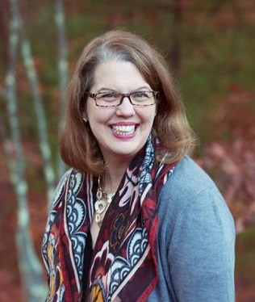 | 25 Forrence Dr. Hollis, NH 03049  617.905.6133  cbell.lewitt@gmail.com  www.relentlesspositivity.org

Sample topics: Relentless Positivity, Gratitude, Present Moment Living, Raising Children with Compassion for Self and Others, Trauma and Development, The Science of Emotion, The Challenge of Change, Four Truths of Happy Living, Mindful Compassion- The Concept of Positive Indebtedness, Reframing Interactions with Teens, Compassionate Communication with Young People, Relationship Reframing, Growing Compassion in Teens

Living in Possibility –
Although you may believe you have little control over your thoughts, your brain can reframe and even reject negative, belittling, bullying ideas, opening the door to thousands of positive moments a day. Charity Bell will share with you concrete, actionable, steps you can take to transform the manner in which you experience yourself and the world around you. Research demonstrates that you are far more powerful than previously understood, choosing your perceptions and reactions. Improving these choices will also impact how family, colleagues, and customers perceive you, increasing connections, relationships, and outcomes!
Drawing from non-violent communication, brain science, and her own amazing experiences overcoming adversity and reconstructing her own perspective on the world, Charity will leave you feeling empowered and hopeful, with plans to live a happier, healthier, and more contented life.

Charity Bell has been recognized as an “Everyday Hero” by Brian Williams of NBC and featured in Good Housekeeping Magazine for her work with more than 150 foster children in Massachusetts, and now in new Hampshire. After her mothers’ early death, Charity applied to the Peace Corps, and spent 18 months in a remote West African village as the only English speaker within 15 miles. She worked primarily with women and infants and delivered more than 60 babies as a lay midwife. She returned and spent time as the Founding Director of an arts/youth development foundation, as Director of Training for a large child welfare organization, and she also began her life as a foster parent. She has worked mainly with drug addicted newborns, going so far as to take them with her as she pursued a graduate degree at Harvard’s Kennedy School of Government. After working as Director of Training for Boys & Girls Clubs of Boston, She is now the Director of Learning and Development at the Massachusetts Department of Mental Health, NE.
She has spent the past 13 years researching and implementing mindfulness and positivity in environments ranging from after-school programs to schools to government agencies. She is an engaging and inspiring speaker, bringing laughter to the important messages that audience members have called "transforming" and "utterly on-point".

Trainings Developed and Delivered

“Trauma Sensitive Discipline, Discipline strategies that respect children’s pasts”
“Verbal De-Escalation- Person centered approaches to intense interactions”
“What to do in an Emergency: Planning for the worst for foster families”
“It’s Not Them, It’s You- Your Power in Conflict”
“Self-Compassion, Changing Your Internal Dialogue”
“What Happens After You Leave: Giving social workers a look at the first night of a placement”

Sampling of Recent Presentations
Keynote, Massachusetts Mentoring Conference
Training, National Conference on School Climate and Culture
Keynote, National Conference on School Climate and Culture
Ongoing work with Pittsfield Maine School System, implementing Positivity Infused Learning Environment
Gratitude Training, Hollis Schools
Keynote and Sessions, Massachusetts Interscholastic Athletic Association
Keynote and Sessions, Kennebunk, ME Schools
Keynote and Sessions, Littleton, MA Schools
Fundraising Event Keynote, Harbor Homes, Nashua, NH
Keynote and Sessions, Department of Transitional Assistance, MA
Keynote and Sessions, Human Service Agencies MA/NH/ME
Staff Training for Bluebird Biotech, Cambridge, MA
Lovepop Cards, Boston MA
Delta Dog, Hollis, NH

