MEDITECH Installation Guide for VPN users

- If you are a first-time MEDITECH user using VPN to login, or you are using a new PC or laptop, please follow these steps:
  - Login to your state-issued VPN. Please make sure the VPN application you use is currently approved to access the network.
  - Login to the PC/laptop with Admin rights on your pc or laptop. If you do not have Admin rights, the following steps may not be allowed. An Admin must perform the following steps.
  - Update the host file as follows:
    - Open C >> Windows >> System32 >> Drivers >> Etc >> hosts
    - Remove 170.63.206.85 care-services.ehs.state.ma.us if it’s in this hosts file
    - Copy and paste the line below into the hosts file, Enter and Save
170.63.93.28 ehealth.ehs.mass.gov
  - Enter and Save.
  - The MEDITECH user should then login to Citrix and MEDITECH as follows

- The URL is https://ehealth.ehs.mass.gov

- You should use Chrome or Internet Explorer to login to MEDITECH. If your preferred browser is Chrome, continue with Step 4 below. If IE is your preferred browser, skip to Step 5.

- Log into Citrix with your current Citrix username and password:
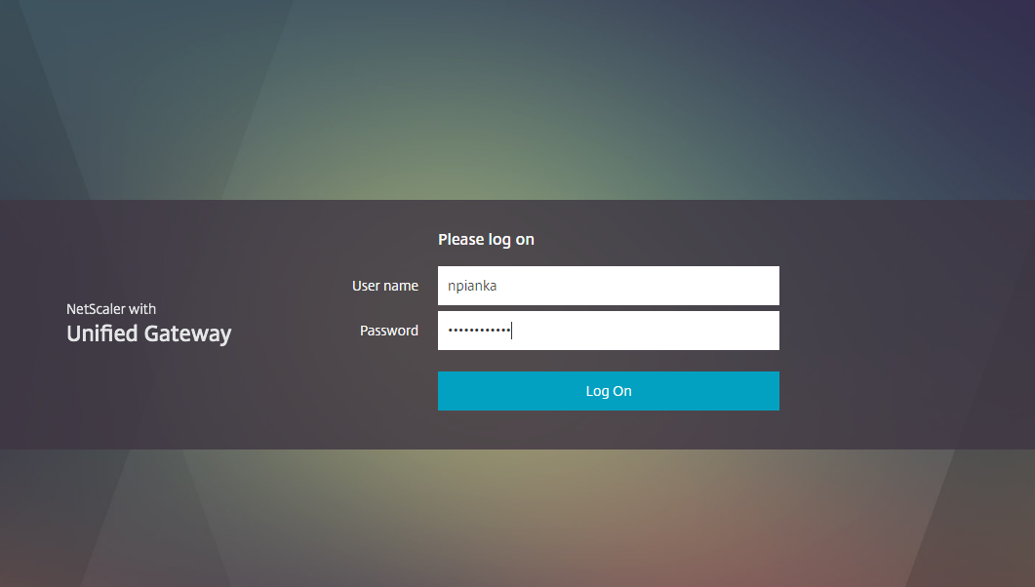

If this page appears, click on Detect Receiver
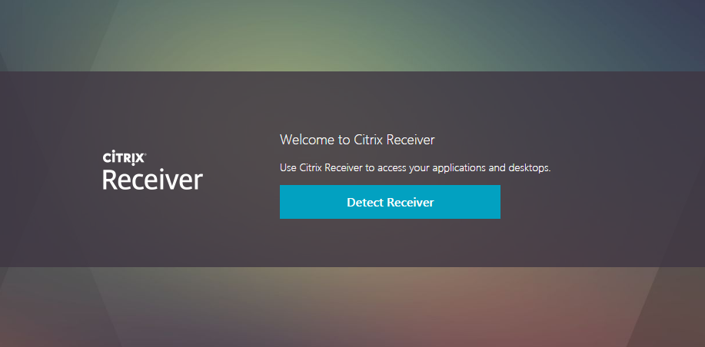

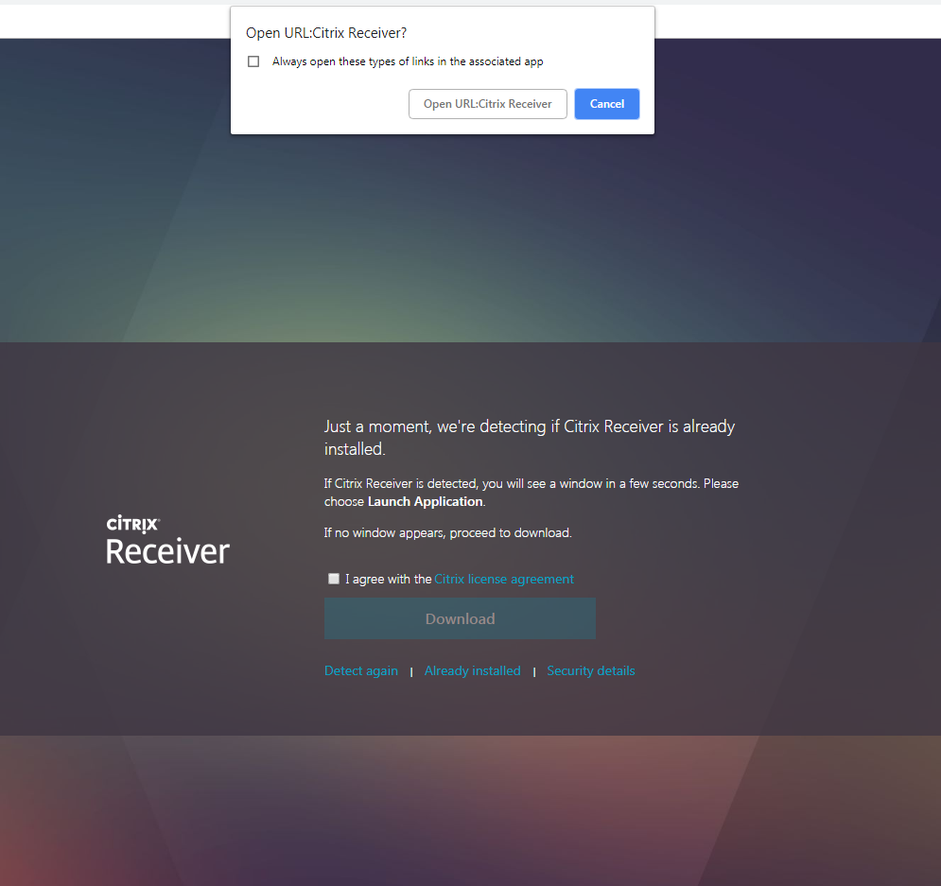
1 – check off ‘Always Open…’
4 – click Download
3 – click ‘I Agree…’
2 – click ‘Open URL Citrix Receiver’
Click on the green MT icon and log in with your existing MEDITECH user id and password.
Proceed to step 8

- For IE users: Click on the link below to open the MEDITECH Citrix Portal.
https://ehealth.ehs.mass.gov

- Log into Citrix with your Citrix user id and password.
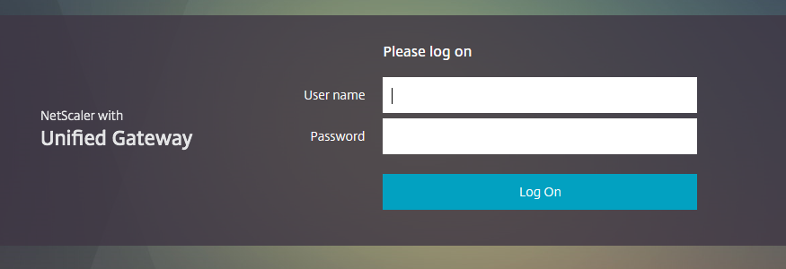
- Click on the green MEDITECH icon.
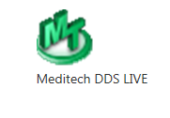
- Click OK on the access Warning message.
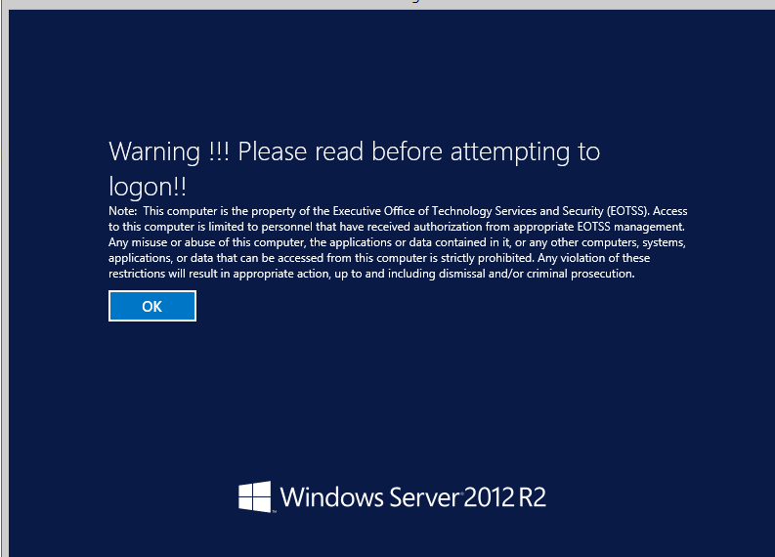
- Log into MEDITECH with your MEDITECH username and password.
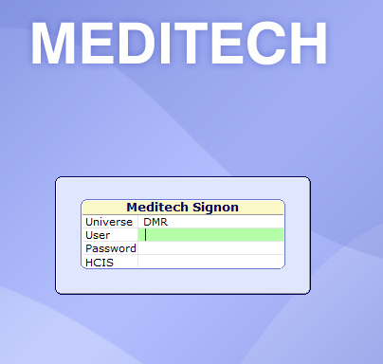
Troubleshooting:
Note: It is not necessary to use compatibility view with this version of Citrix.
Issue 1: The message below keeps appearing at the bottom of Internet Explorer.

Resolution to Issue 1: You must add https://ehealth.ehs.mass.gov to the trusted sites in Internet Explorer. You may need someone who is an administrator on your PC to do this if you are unable to do so yourself. DDS employees – if you are using a DDS laptop or PC, this site should already be in the ‘Trusted Sites’ on your computer.

If you are unable to login to VPN or Citrix/MEDITECH after following these instructions, or you need a Citrix or MEDITECH Password reset, or if you have a question or issue related to MEDITECH, please call the Customer Service Center at 617-994-5050 (VOIP 994-5050). Please be ready to describe which steps you are having trouble with (e.g. VPN, Citrix, or Meditech).

