DDS SOUTHEAST REGION LEARNING AND DEVELOPMENT CALENDAR

September, October, November
2017



I am pleased to share with you the Fall Calendar of Training Events for the Southeast Region. The process of learning is never ending. Amidst our busy schedules, it is often difficult to find the time to participate in a learning opportunity. I invite you to select one or two learning opportunities that will enhance your own professional development. We have a variety of trainings such as Social Role Valorization, Regional Leadership Series, EO509 Nutrition classes, Plymouth Area PBS Series and many more to choose from. Offered for the first time Pathways to “The Good Things in Life” on October 30th & 31st.
Please let me know if you have any recommendations for future trainings.
Enjoy!
Dianne Rodrigues
Director of Learning and Staff Development

Southeast Regional Training Committees

- Regional Training Council
- Brockton/South Costal Training Committee
- Fall River Training Committee
- New Bedford Training Committee
- Plymouth Planning Committee
- Cape & Islands Training Committee
- Taunton/Attleboro Training Committee
- Regional Leadership Series Committee
- Southeast Residential Training Committee/Diversity Committee
- Wrentham Training Committee
- Regional Diversity/Inclusion Committee
- Wrentham Diversity Committee
- Orientation/Training Committee
- Nursing Education Series (NES)



Registration: unless otherwise indicated, email: Raquel Pereira at
Raquel.Pereira@massmail.state.ma.us

PLEASE NOTE: Registration will begin 15 minutes before class starts. In consideration of our presenters, please make every effort to be punctual. Your cooperation will enable a positive learning experience and reduce interruptions.

Please provide the following information:

How to Register:

    - Name/names of staff you wish to register
    - Name of class
    - Date of class
    - Contact information including:
      - Name of contact person
      - Name of agency
      - Phone number of contact person
      - Email of contact person
      - Any necessary accommodations
For CPR/First Aid Classes at Wrentham: refer to calendar for contact person.
WEATHER INFORMATION 

Cancellation (day) of training occurs when the Governor declares a STATE OF EMERGENCY.
For cancellation of Regional Trainings please check the DDS Learning Site @ www.ddslearning.com

For cancellation of classes held at Wrentham Developmental Center, please call (508) 384-1654.

TABLE OF CONTENTS

September, October, November
2017

American Red Cross – Water Safety Today 48
American Heart Association HeartSaver First Aid 17
Awareness & Action Training 50
Basic Fire Safety Training 18
Be A Better…Healthy Meal Planner 35
Bristol Community College 21
Build A Better Lunch 43
Calendars (September - November) 10,11,12
Choosing Which Service Method is Best for You 41 & 42
Complaint Process 34
Diabetes (Fall River A.O. – Support Group) 33
Diabetes 101 29
Diabetes 47
DDS Learning Website 7,8
DDS Orientation (DDS Employees only) 6
Direct Support Certificate Program 45 & 46
Direct Support Professionals 43,44
Directions 65,66,67
Disability Law Center 58
Family Support Centers 54,55,56
Falls Prevention Training 44
Food for Health 49
HeartSaver CPR 17
History of Human Services 22 & 23
How to Reach Us 9
Integrity in Human Services 27
HealthCare Provider CPR (BLS-Basic Life Support) 17
Healthy Aging & Dementia 22

Leadership Series Letter; Application & Schedule 14,15,16
Massachusetts Advocates Standing Strong 51
Medication Administration (MAP) 20
MFOFC (Family Leadership Series) 59 - 63
MTI (Mass Tex Imaging – Dysphagia) 64
NAMI Basic 39 & 40
NVMAB 19
Office for Human Rights 13
Pathways to “The Good Things in Life” 30
PBS: PBS & Person-Centered Planning 32
PBS: Taking Accurate & Meaningful Data 32
PBS: Visual & Environmental Supports 32
Rainbow Support Group of Massachusetts 52
Resources 53 Respiratory Update 24
Registration 4
Save the Date Page 57
Seizure Training 28
Self-Determination, the Next Horizon 40
Self-Direction & Crafting a Positive Vision 31
Shaping One’s Destiny 26
Southeast Regional Training Committees 3
SRV 24 & 25
The History of Human Services 22 & 23
The Process of Problem Solving 26
Train the Trainer Project: Human Guide & Vision Loss 36 & 37
Transition Into Adulthood 31
Weather Information 4
Well Adapted Water Safety Training 38

PLEASE NOTE: There will not be a calendar for December, only stand alone flyers.

DDS Orientation for all new Southeast Region staff is offered quarterly, this quarter is scheduled for
September 19th, 20th, 21st, 22nd; All new SRS employees are required to attend. September 25th; 26th; 27th; 28th & 29th; All new DDS employees are required to attend.
November 28th, 29th, 30th & December 1st; All new SRS employees are required to attend. December 11th, 12th, 13th, 14th; 15th All new DDS employees are required to attend.

Topics include:

- Welcome and Introduction to State Services
- History of Department of Developmental Services
- Basic Human Rights (prerequisite for Human Rights Systems/Advocates)
- Understanding the People We Support
- Confidentiality is a Right to Privacy (HIPAA)
- Diversity (full day)
- Diversity (half day – additional requirement for managers)
- Sexual Harassment Prevention
- Workplace Communication
- Team Building
- Understanding Valued Roles
- Understanding the importance of Relationships and Friendships
- Introduction to Positive Behavioral Supports
- Confidentiality

In addition to the DDS Orientation classroom training, ALL NEW EMPLOYEES must ALSO take the Mandatory EOHHS Administrative Training found on-line at www.pace.state.ma.us. These required trainings include: Human Service Worker Safety, Workplace Violence, Domestic Violence, Conflict of Interest, Parts 1 and 2, Sexual Harassment, Confidentiality, Disability Awareness.

Additional topics for SRS (and direct support) include: Coaching the Van Driver, Medical Documentation, Sensitivity Training, Personal Care Needs, and Dysphasia, Adaptive Equipments Safety and Maintenance, Lifting, Introduction to Sign Language, and Water Safety….

Additional learning opportunities are available at www.ddslearning.com website.

When registering for any of our trainings, please make us aware of any reasonable accommodations that you may need. Please provide a two week notice.
Please register with: Kristin.Dupuis@state.ma.us
Please be on time.

DDS Learning
Website

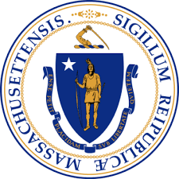
What’s available on the website?

All the current information regarding the PBS initiative

All the learning calendars
Information specific to:

- Developmental Disabilities
- Autism Spectrum Disorder
- Aquired Brain Injury
- Smith-Magenis Syndrome
- Prader-Willi Syndrome
- The Real Lives Bill
- The Direct Support Certificate Program

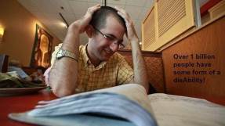

Valarie Whiting, PhD
Statewide Training and Staff Development Director
500 Harrison Blvd
Boston, Ma 02108
617-624-7731
Regional Training and Staff Development Directors:
Pat Cronin, North-East
Denise Kellett, Metro
Dianne Rodrigues, South-East
Tom Winans, Central-West

Welcome to the Massachusetts Department of Developmental Services Learning Website

DDSLearning is a free
learning resource.





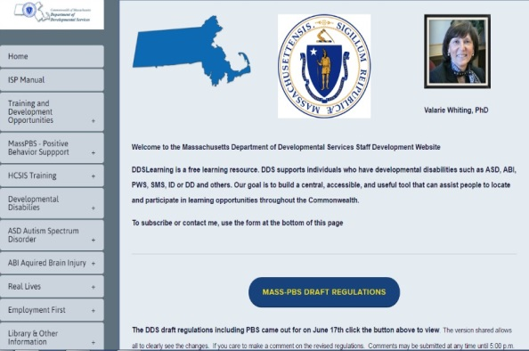
Directions to use DDSLearning.com for PBS online training, materials, resources and regional training calendars
DDSLearning is a free learning resource. DDS supports individuals who have developmental disabilities such as ASD, ABI, PWS, SMS, ID or DD and others. Our goal is to build a central, accessible, and useful tool that can assist people to locate and participate in learning opportunities throughout the Commonwealth.


Directions to use DDSLearning.com for PBS online training, materials, resources and regional training calendars
DDSLearning is a free learning resource. DDS supports individuals who have developmental disabilities such as ASD, ABI, PWS, SMS, ID or DD and others. Our goal is to build a central, accessible, and useful tool that can assist people to locate and participate in learning opportunities throughout the Commonwealth.
Regional Training Calendars

The statewide training calendars are published quarterly on the ddslearning.com website.

Registration directions are included in each calendar.

Any changes to the schedules are maintained on the website.
Calendars are published quarterly: January through March, April through June, July through September, and October through December.

Here is how you get to the training calendar:
Using Google Chrome

(DO NOT use internet explorer it does NOT work)

Open a search tab and simply enter the words ddslearning.com
The home page opens up.

Next on left CLICK Training and Development Opportunities

Next on left CLICK Learning Calendars
Here you will see the link to all four regional offices. CLICK the calendar or information you want to access.

DDS SOUTHEAST REGION
LEARNING & DEVELOPMENT

HOW TO REACH US

Department of Developmental Services
151 Campanelli Drive, Suite B
Middleboro, Ma 02346

General Office Number: 508-866-5000

Learning and Development Team

Dianne Rodrigues, Director
dianne.rodrigues@massmail.state.ma.us
Phone: 508-866-8879

Raquel Pereira, Admin
raquel.pereira@massmail.state.ma.us
Phone: 508-866-8874

Rebecca Morrissey, Trainer rebecca.morrissey@mass.mail.state.ma.us
Phone: 508-866-8865

Maureen O’Rourke-King, Trainer maureen.king@massmail.state.ma.us
Phone: 508-866-8863 (Regional)
508-732-5725 (Plymouth)

Wrentham Developmental Center
131 Emerald Street
Wrentham, MA 02093

Tony Marano, Trainer
tony.marano@massmail.state.ma.us
Phone: 508-384-1654

Southeastern Residential Services (SRS)
151 Campanelli Drive, Suite B
Middleboro, Ma 02346

General Office Number: 508-910-3000

George McCauley, Personnel Training
George.McCauley@massmail.state.ma.us
Phone: 508-910-3002

SEPTEMBER 2017
Monday | Tuesday | Wednesday | Thursday | Friday
 |  |  |  | 1
4   | 5  BCC Classes Begin | 6  Shaping One’s Destiny  9:30 am – 12:00 pm  (Middleboro) | 7 | 8
11  Seizures, 12:30-2:00PM  Conant Center  Human Rights Officer Training 10:00 am – 2:30 pm (Middleboro) | 12  BLS/CPR – 8AM-12PM (WDC) | 13  Human Rights Officer 10am-2:30pm (Middleboro) | 14 | 15
18 | 19  SRS – Orientation 8:30 am – 5:00 pm | 20  SRS – Orientation 8:30 am – 5:00 pm  PBS: Visual & Environmental Supports  Plymouth Area Office 9:30 am – noon  Diabetes (Support Group)  3:00 pm (Fall River Area Office) | 21  SRS – Orientation 8:30 am – 5:00 pm | 22  SRS – Orientation 8:30 am -5:00 pm
25  DDS Orientation 9:00 am – 5:00 pm | 26  DDS Orientation 9:00 am – 5:00 pm | 27  DDS Orientation 9:00 am – 5:00 pm  Train the Trainer (Worcester) | 28  DDS Orientation 9:00 am – 5:00 pm | 29  DDS Orientation 9:00 am – 5:00 pm  CPR – Basic Life Support  8:00 am – 12:00 pm (WDC)

OCTOBER 2017
Monday | Tuesday | Wednesday | Thursday | Friday
2  MAP 9:00 am – 3:00 pm (Middleboro)  SRV – 8:30 – 5:30 pm  (Mattapoisett) | 3  MAP 9:00 am – 3:00 pm (Middleboro)  Diabetes 101 – 10-12 (Bridgewater)  SRV– 8:30 am– 5:30 pm – (Mattapoisett)  (Mattapoisett)  The Process of Problem Solving  9:30 am – 12:00 pm – (Middleboro) | 4  SRV– 8:30 – 5:30 pm  (Mattapoisett) | 5  SRV– 8:30 – 5:30 pm  (Mattapoisett)  Dysphagia 1PM-3PM  BAMSI Foxboro Training Center | 6  Shaping One’s Destiny  9:30 am – 12:00 pm  (Middleboro)
9   | 10  Human Rights Coordinator Training 10:00 am – 12:00 pm (Middleboro) | 11 | 12 | 13  Build A Better Lunch  10:00 am – 12:00 pm  (Conant – Bridgewater)
16  Regional Training Council Planning Day ~ Fall River | 17  Human Rights Officer Training 10:00 am – 2:30 pm (Middleboro) | 18  Train the Trainer (Worcester)  BLS/CPR 8am – 12pm (WDC)  PBS: Taking Accurate & Meaningful Data Plymouth Area Office  9:30 am – 12:00 pm | 19 | 20  Falls Prevention 10AM-12PM  Conant – Bridgewater  Basic Fire Safety Training  9:00 am – 1:00 pm  Middleboro  Be A Better Healthy Meal Planner  1:00PM-3:00PM  Conant Center – Bridgewater
23 | 24 | 25 | 26  Compassionate Conversations  1:00 pm – 4:00 pm  (Middleboro) | 27  Complaint Process 10:00 am – 12:00 pm (Middleboro)  CPR – Basic Life Support  8:00 am – 12:00 pm (WDC)  Diabetes – 10:00 am – 2:00 pm  (Conant – Bridgewater)
30  Pathways to “The Good Things in Life”  Central Congregational Church, Middleboro 9:00 am – 5:00 pm | 31  Pathways to “The Good Things in Life”  Central Congregational Church, Middleboro 9:00 am – 5:00 pm

NOVEMBER 2017
Monday | Tuesday | Wednesday | Thursday | Friday
 |  | 1  Regional Leadership Series – Kick-Off  Integrity in Human Services  9:30 am – 12:00 pm  (Middleboro) | 2 | 3  Diabetes 101  10AM-12PM  Conant Center
6 | 7 | 8 | 9 | 10
13  History of Human Services (Sea Crest Beach Hotel – North Falmouth) | 14  History of Human Services (Sea Crest Beach Hotel– North Falmouth) | 15  Train the Trainer (Worcester)  Basic Fire Safety Training  9:00 am – 1:00 pm  (Middleboro)  EO509 Healthy Holidays!  12:30-2:30 Fall River Area Office | 16  Human Rights Officer Training 10:00 am – 2:30 pm (Middleboro)  Heather Saver CPR – 8am – 12pm (WDC)  PBS & Person-Centered Planning  Plymouth Area Office  9:30 am – 12:00pm | 17  CPR – Basic Life Support  8:00 am – 12:00 pm
20 | 21  Basic Fire Safety Training  9:00 am – 1:00 pm  (Middleboro) | 22 | 23   | 24
27 | 28  SRS – Orientation 8:30 am – 5:00 pm  DDS Orientation December 11 - 15 | 29  SRS – Orientation 8:30 am – 5:00 pm | 30  SRS – Orientation 8:30 am – 5:00 pm | December 1  SRS – Orientation 8:30 am – 5:00pm

OFFICE FOR HUMAN RIGHTS

In affirming, promoting and protecting the human rights of individuals with intellectual disabilities, the Office for Human Rights offers: networking, training (staff, self-advocates, committees, advocates, etc.), consultation and/or direct advocacy in complex or difficult situations and, information on any Human Rights questions.

In the Southeast Region, to access the Office for Human Rights, please contact Nate Hoover, Human Rights Specialist, 508-866-8916 or
by e-mail: nathan.hoover@state.ma.us

Human Rights Coordinator Training
This presentation is geared toward current and new provider human rights coordinators and presents the nuts and bolts of fulfilling the role. The training will include a discussion regarding recruiting HR committee members, how to navigate HCSIS and present information to committees, guidance regarding incident and restraint report review, etc.

Tuesday, October 10, 2017 – 10:00 am – 12:00 pm

Human Rights Advocacy for All Training
(Officer Training)
This is the approved curriculum for staff to be certified as Human rights Officers/Advocates

Monday, September 11, 2017 – 10:00 am - 2:30 pm

Tuesday, October 17, 2017 – 10:00 am – 2:30 pm

Thursday, November 16, 2017 – 10:00 am – 2:30 pm

All classes are offered at:

DDS Southeast Regional Office 151 Campanelli Drive, Suite B, Room 106
Middleboro, MA

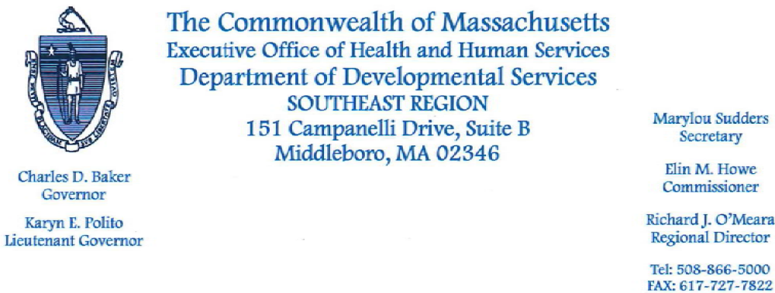
July 26, 2017

Dear Colleagues:

I think you would agree with me that as our community system and workforce matures it is more important than ever to do everything possible to support leadership development. Many of the challenges faced years ago by consumers and their families still exist today, and it is critical that we continue to support the personal and professional development of individuals called to respond to these challenges. For this reason and the belief that a new generation of leaders must be cultivated if the gains we have made the past 30 plus years are to be sustained, the Southeast DDS Region is once again pleased to be sponsoring its leadership training series, "Developing Leadership: A Personal Journey."

The number of available slots is extremely limited so I encourage you to act and act quickly to encourage any qualified candidates to apply. Perhaps you are interested, or know of a staff member, parent, board member or consumer who you feel has made an exceptional commitment to people with intellectual, brain injuries or other developmental disabilities, who would benefit from this experience.

The leadership series is of high quality and beneficial to everyone who participates. Our lead trainer, Deborah Reidy, has worked with leaders in nonprofits, community organizations and government for many years and recently published a book, "Why Not lead? A Primer for Families of People with Disabilities and their Allies." I hope you agree with me on the need for this kind of experience and give it your serious consideration. If you would like more information please contact Dianne Rodrigues at 508 866-8879 and she would be happy to speak with you.


Richard J. O'Meara Regional Director

DDS Southeast Region
“Developing Leadership: A Personal Journey”
APPLICATION
FY 18

Return application by September 15, 2017 to Dianne Rodrigues at 151 Campanelli Drive, Middleboro, MA.02346 or fax to Dianne at 617 727-7822 or email application to Dianne.Rodrigues@state.ma.us.

NAME:

SERVICE ROLE:

ADDRESS:

TELEPHONE:

EMAIL:

REFERENCES:

NAME: TELEPHONE NUMBER:

NAME: TELEPHONE NUMBER:

How did you learn about the leadership series: ______________________________________

Please write, or attach, a letter which tells us something about who you are and why you are interested in participating in the leadership series “Developing Leadership: A Personal Journey”. Please include the names and telephone numbers of two people we may call as references. Applicants will be interviewed and approximately twenty will be selected by the Region’s Leadership Development Team. There is a $250.00 registration fee for applicants accepted into the leadership series. Scholarships may be available for people with disabilities and family members.

If you have any questions about the Leadership Series, please contact Dianne Rodrigues at 508-866-8879 or Jack Yates at 508-999-4436.

Regional Leadership Series
2017 - 2018 SCHEDULE
November 1, 2017 9am-5:00pm Welcome, Introductions and Expectations --
Rick O’Meara and the
Leadership Development Team

November 27, 2017 – November 30, 2017 8am-5:30pm “Social Role Valorization” (SRV) – Jo Massarelli

January 23, 2018 9am-5:00pm “Implementing SRV: Crafting Valued Roles for
One Person” – Jo Massarelli

January 24, 2018 9am-5:00pm “Inviting Responses to SRV – Jack Yates
“Supporting Community Relationships/Belonging” - Tom Doody

February 13, 2018 9am-5:00pm “Leadership” -- Deb Reidy

February 14, 2018 9am-5:00pm “Partnering with Families” –
Emily Murgo Nisenbaum

March 6, 2018 9am-5:00pm “Skillful Communication” – Deb Reidy

March 7, 2018 9am-5:00pm “Leading Through Conflict” – Deb Reidy

March 20, 2018 9am – 5:00pm Finding your voice – Jo Massarelli

March 27, 2018 Snow Date

April 3, 2018 9am-5:00pm “Personal Influence and Leadership in Practice” -
Deb Reidy

April 4, 2018 9am-5:00pm “Partnering With the People Who Receive
Supports” – Maureen King, Kathleen Amaral and
Jake Hall

April 17, 2018 9am-1:00pm Capstone - Mark Sanderson and Leadership Team

Participants are expected to attend all fourteen sessions.

All classes are held at: Nemasket Group Inc.
109 FairHaven Road
Mattapoisett MA 02739
508 999-4436
“If your actions inspire others to do more and to become more, then you are a leader”
--John Quincy Adams


AMERICAN HEART ASSOCIATION HEARTSAVER FIRST AID

The purpose of the Heart saver First Aid Course is to teach rescuers the knowledge and psychomotor skills they need to recognize emergencies at the worksite and give first aid. The First Aid section is approximately three hours and the CPR component is a separate three-hour class. The certificate is renewable every two years.

Cost $28.00. ($20.00 book & $8.00 for card) Participants must bring cash or check made out to WDC.

Wednesday, October 18, 2017 - 8:00 am – 12:00 pm
Wednesday, January 17, 2018 - 8:00 am – 12:00 pm

Register: Kathy Stoffel - 508-384-5538
WDC – 23 Finch Road, Wrentham, Ma
(The Gail Parslow Training Center)

Saturday, October 14, 2017 – 8:00 am – 12:00 pm
Saturday, November 4, 2017 – 8:00 am – 12:00 pm
Friday, December 29, 2017 – 8:00 am – 12:00 pm

Register: Jill Blais- Pignolet – 508-384-5643 (office)
- 401-474-2878 (cell)

HEARTSAVER CPR

The Heart saver CPR program is designed to teach CPR and relief of foreign body airway obstruction to all lay rescuers, such as school children, family members of people at high risk for sudden cardiac death. It is specifically designed for lay rescuers who are required to obtain a course completion card, a credential documenting completion of a CPR course. All rescuers are trained in CPR and relief of FBOA. This program teaches CPR and relief of foreign body airway obstruction for adult victims or infant and children victims in approximately 3 hours and for adult, infant and children victims. The course includes learning opportunities, including a videotape presentation of the chain of survival and warning signs of cardiovascular emergencies. You will learn to use an automated external defibrillator AED. Instructor-led discussion to reinforce the signs of heart attack, cardiac arrest, stroke and choking. Videotaped skills demonstration and practice, instructor-led practice scenarios, and peer-practice sessions.
Participants must bring cash or check made out to WDC. Cost $38.00. ($20.00, book, $10.00, mask & $8.00 for card)

Thursday, November 16, 2017 – 8:00 am – 12:00 pm
Thursday, February 15, 2018 – 8:00 am – 12:00 pm

Register: Kathy Stoffel 508-384-5538

WDC – 23 Finch Road, Wrentham, Ma
(The Gail Parslow Training Center)

HEALTHCARE PROVIDER CPR (BLS-Basic Life Support)

The BLS for Healthcare Provider course is designed to teach the skills of CPR for victims of all ages (including ventilation with a barrier device, a bag mask device, use of an automated external defibrillator (AED) and relief of foreign body airway obstruction. It is intended for participants who work in a Healthcare setting and those who are required to take a Healthcare Provider course for their employment. A course completion card is issued for all participants in a BLS for Healthcare Providers course whom successfully complete the written examination and skill demonstration.

Participants must bring cash or check made out to WDC. Cost $38.00. ($20.00, book, $10.00, mask & $8.00 for card)

Tuesday, September 12,2017 – 8:00 am – 12:00 pm
Tuesday, December 5, 2017 - 8:00 am – 12:00 pm

Register: Kathy Stoffel 508-384-5538
WDC – 23 Finch Road, Wrentham, Ma
(The Gail Parslow Training Center)

Friday, September 29, 2017 – 8:00 am – 12:00 pm
Friday, October 27, 2017 – 8:00 am – 12:00 pm
Friday, November 17, 2017 – 8:00 am – 12:00 pm
Sunday, December 10, 2017 – 8:00 am – 12:00 pm

Register: Jill Blais- Pignolet – 508-384-5643 (office)
- 401-474-2878 (cell)



BASIC FIRE SAFETY TRAINING

The primary purpose of fire safety training is to give staff an orientation to the actions they can take to prevent as well as respond to a fire in a home. The training emphasizes prevention, preparedness and response. Through lecture, slide and video format, trainers sensitize staff to the serious consequences of a fire and the importance of developing an effective evacuation plan and practicing the evacuation procedures so that everyone is aware of what to do in a fire emergency. It will provide participants with basic information about the causes and types of fires, as well as fire prevention, hazard identification, smoke and smoke detectors, and evacuation procedures. Prevention, preparedness, types of fire extinguishment, and response are the key elements of this training.

This curriculum is the DDS approved Fire Safety Training

To receive a certificate, individuals must attend the entire training. Participants will be responsible for ensuring their agency receives a copy of their certificate.

No one will be admitted to Basic Fire Safety Training after the first fifteen minutes so please be on time.

Presented by: Al Murrant

Date: September 20, 2017
November 15, 2017
November 21, 2017

Time: 9:00 am – 1:00 pm

Place: Regional Office
151 Campanelli Drive,Suite B
Conference Room 100
Middleboro, MA

Registration: raquel.pereira@massmail.state.ma.us

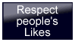

NON-VIOLENT MANAGEMENT OF
AGGRESSIVE BEHAVIOR – Refresher Course

Presented by: Brian Donahue;
Kyle Grace

This course is designed to help refresh the skills that you learned in the full course and is required to maintain certification. Prior NVMAB certification is a prerequisite. We will also update you on changes in NVMAB, regulation and policy that may have occurred.

Participation and attendance is required at BOTH sessions. All who are interested are encouraged to attend regardless of their physical limitations. Please wear loose and comfortable clothing.

TO MAINTAIN NVMAB CERTIFICATION ATTENDANCE IS MANDATORY FOR BOTH CLASSES OF THIS SERIES.

If you have any questions please contact Kyle Grace @

kyle.grace@massmail.state.ma.us



NON-VIOLENT MANAGEMENT OF
AGGRESSIVE BEHAVIOR

Presented by: Brian Donahue;
Kyle Grace

This course is designed to teach how to prevent and minimize crisis situations where a person’s behavior has the potential to cause serious injury to themselves or others. Interventions are taught progressively from the least intrusive (verbal interventions, deflecting, blocking, escorts, etc.) to the most intrusive (Physical Restraint).
Participation and attendance is required at ALL sessions. All who are interested are encouraged to attend regardless of their physical limitations. Please wear loose and comfortable clothing.
The first class also fulfills the requirement for staff to be certified as Restraint Monitors/"Specially Trained Staff"

TO BECOME NVMAB TRAINED ATTENDANCE IS MANDATORY FOR EACH of the FIVE CLASSES.

Please look for individual flyers with class dates.

Medication Administration
MEDICATION ADMINISTRATION
TRAINING & TEST REQUIREMENTS

As of July 1, 2011 D & S Diversified Technologies has been awarded the contract to conduct testing for the certification of staff to administer medications. Providers and MAP trainers will be able to access testing statistics and specific performance issues via an internet portal. Results of computer based testing will be available within 24-48 hours. The company may be reached by calling 1-877-851-2355. If calling, please ask to speak to a member of the Massachusetts team; as they provide services to other states. Their fax number is 419-422-7395. Web address is www.headmaster.com. Please refer to the information within your agency for any questions and clarification you many have concerning this new process or contact one of the nurses listed to the right.

TRAIN THE TRAINER
Training for RNs working for service providers to become instructors in the Medication Administration Program will be provided on a regularly scheduled basis.

The dates for this year are:
September 27th, October 18th & November 15th

The classes will be held at 324 Clark Street, Worcester, MA.

Please contact Susan Canuel, RN at (508) 866-8812 with any questions and/or to register.

Medication Administration
For initial certification training, medication, and recertification review please call the nurse-trainer in your area to receive dates of scheduled classes or to schedule agency specific training.

Southeast Region Area Office Nursing Support

Regional MAP Coordinator
Susan Canuel, RN
susan.canuel@massmail.state.ma.us 508-866-8812

DDS South Coastal Area Office
Nancy Noble, RN
nancy.noble@massmail.state.ma.us 781-337-1312

Irene Loria, NP
irene.loria@massmail.state.ma.us 781-356-8850

DDS Brockton Area Office
Donna Gray, RN 774-296-6341
donna.gray@massmail.state.ma.us

Deborah Moore, NP 774-296-6402
deborah.m.moore@massmail.state.ma.us

DDS Cape Cod Area Office
Eileen Hawe, BSN, MS, MSN, ARNP-C
Eileen.Hawe@massmail.state.ma.us 508-790-6109

DDS Fall River Area Office
Sherri Schoorens, RN
sherri.schoorens@massmail.state.ma.us 508-730-1308

Liz King, NP
eking@massmail.state.ma.us 508-730-1307

DDS New Bedford Area Office
Kate Smith
kathyrn.smith@massmail.state.ma.us 508-992-1327

DDS Taunton/Attleboro Area Office
Donna Stone, RN
donna.stone@state.massmail.ma.us 508-824-0614

DDS Plymouth Area Office
Siobhan Manning
siobhan.manning@massmail.state.ma.us 508-732-5710

ABI/MFP
Jessica Stad
Jessica.stad@massmail.state.ma.us 508-866-8895

Dianna Souza 508 -866-8824
Dianna.Souza@massmail.ma.us

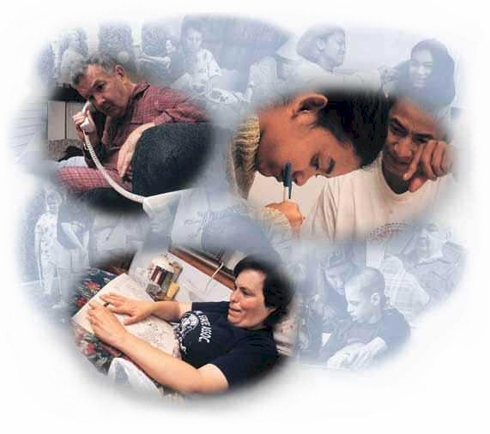
BRISTOL COMMUNITY COLLEGE DEVELOPMENTAL DISABILITIES / DIRECT SUPPORT CERTIFICATE PROGRAM
Earn a Developmental Disabilities
Certificate of Achievement

Fall Classes begin on Tuesday,September 5, 2017. Application due by 8/29/17
Spring classes begin on Tuesday,January 23,2018 Applications due by 1/9/18
Take classes on Tuesday and/or Thursday afternoons and begin to learn more about people with intellectual disabilities. Topics covered include: defining developmental disabilities, prevalence of various conditions and theoretical perspectives and causes.

Direct support workers who are employed at a state agency or an agency under contract with DDS, have a GED or high school diploma, and have the support of their employer are eligible to apply.

The entire program is based on the National Community Support Skill Standards, a set of skills and competencies used by outstanding direct support staff in their work. This program is affordable because of the financial support from DDS and its partnership with the community colleges.

Cost: $50 registration fee/course/books
Often paid by your employer

Date: Classes begin Tuesday, September 5, 2017

Class times: Tuesdays & Thursdays, 2:00 PM - 4:40 PM
Fall River Campus/ Bristol Community College

Courses: College Writing
General Psychology
Introduction to Social Welfare
Developmental Disabilities
Special Topics
Supervision & Leadership
Field Experience/Internship & Seminar

For Additional Information Contact: Paul F.Correia, Bristol Community College, 508 678-2811, extension 3765 or paul.correia@bristolcc.edu

Community Systems, Inc., is pleased to announce a two-part, two-day presentation by the Training Institute on

The History of Human Services
with emphasis on the origins of some of our major contemporary service patterns & some universal lessons for the planning & structuring of our services which can be learned from this history
Date & time: Monday, November 13 and
Tuesday, November 14, 2017
8:30 am to 4:30 pm each day.
Location: Sea Crest Beach Hotel, 350 Quaker Road, Falmouth, Massachusetts 02556
Tuition: $200 (includes lunch & refreshments each day). Thanks to the generosity of our sponsors, a limited number of partial scholarships are available. We encourage you to call the registrar for more information.
Registrar: Maria Campbell, 774-313-8550 or maria.campbell@csi-ma.org

Format of workshop: The presentation will be conducted in lecture style with extensive visual aids. there will be breaks for refreshments about mid-morning & mid-afternoon, as well as lunch (provided as part of the fee). There will be questions & discussion at the end of each day.
To register: Please complete the registration form on the second page of this flyer.
Brief workshop description: Using more than four hundred slides, this presentation documents the evolution of major human service concepts & practices from ancient, informal, voluntary, unpaid personal helping forms to the largely commercialized patterns of today. The presentation is conducted in two parts, each part taking up a full day. In both parts, illustrations of the architecture of human service settings will be used to show historic service patterns & assumptions. There will be time for questions & discussion at the end of the presentation each day.
The presentation demonstrates the evolution of the human service ideas that bigger services are better services; that afflicted people are a menace to society; that segregated services are preferable to integrated ones; & that service recipients should be thankful for what they receive from service workers. The presentation also demonstrates that human service concepts leapt across barriers of language, nations & culture, as early as medieval times.
The presentation compellingly shows, as well, how human services are more effective when they are deeply rooted in the historical traditions & values of their culture, & that the drift of services away from cultural-rootedness & towards non-normative & culture-alien approaches contributes so much of the current service disfunctionality.
Altogether, the presentation shows that today’s human services are full of practices which are carried on unconsciously but which are vestiges or distortions of practices originally instituted with high consciousness.
This workshop was developed by Dr. Wolf Wolfensberger, and is taught by Susan Thomas and others of his associates.
The presentation addresses the history of human services of all types (medical, residential, detentive, etc.) & for all types of people (sick, poor, impaired, etc.). Thus, people in all service fields will find the presentation relevant.

First day: The first day sketches important prehistoric, Greek & Roman, early Christian & medieval antecedents of current human service patterns, showing that the history of human services is intertwined with the history of care for the poor & of residential services. The first part concludes by showing how certain service designs & service practices are now the very opposite of what they started out to be.

Second day: The second day elaborates on one particular theme raised on the first day; namely the interpretation of service recipients as menaces, & the structuring of services on that assumption. This menacizing eventually displaced the remnants of more benign perceptions & interpretations of recipients, even down to the present day.
______________________________________________________________________

REGISTRATION FORM
TWO DAY PRESENTATION: “THE HISTORY OF HUMAN SERVICES”
Please type or print legibly.
NAME: _______________________________________________________________

PREFERRED ADDRESS:
______________________________________________________________________
______________________________________________________________________

AGENCY NAME: ______________________________________________________

AGENCY PHONE: _______________________ FAX: _________________________

E-MAIL: ______________________________________________________________

Tuition is $200. Lunches & refreshments are included as part of the workshop fee. Please call the registrar for more information, or to inquire about a partial scholarship: Maria Campbell, 774-313-8550 or at maria.campbell@csi-ma.org . Make out checks to Community Systems, and mail registration and payment to Maria Campbell at 3 Cedarhill Park Drive, Plymouth MA 02630.

If you wish to stay overnight at the Sea Crest Beach Hotel, make reservations by calling the hotel at (800) 225-3110 or by going to www.seacrestbeachhotel.com .

The Massachusetts Alliance for Personal Action is pleased to announce a four-day workshop on

A REVISED CONCEPTUALIZATION OF SOCIAL ROLE VALORIZATION,
INCLUDING 10 RELATED THEMES:
A HIGH-ORDER CONCEPT FOR ADDRESSING THE PLIGHT OF SOCIALLY
DEVALUED PEOPLE, & FOR STRUCTURING HUMAN SERVICES (PART I)

from Monday October 2 through Thursday October 5, 2017 (8:30 am to 5:30 pm)
at Nemasket Group, 109 Fairhaven Road, Mattapoisett MA 02739
Taught by Jo Massarelli & Associates of The SRV Implementation Project

DESCRIPTION OF THE WORKSHOP:

This is part one of a two-part course. (For more on part two, visit http://www.srvip.org/ or email
info@srvip.org). This workshop provides an introduction to Social Role Valorization (SRV),
using the ten core themes, developed by Dr. W. Wolfensberger, considered one of the most
influential thinkers in the field of human services worldwide. Wolfensberger's work helped lay
the foundation for many current human service trends, including integration, safeguarding of
rights, & the deinstitutionalization movement.
SRV is a systematic & universally applicable concept for structuring human services, anchored
in the empiricism of psychology, sociology, & broad human experience. SRV posits a
close relationship between the socially perceived value of the roles that people hold, &
whether people in those roles will be accorded opportunities & other good things of life. Bad
things tend to get done to people who are seen in devalued roles, & good things tend to be
afforded to people in positively valued roles.
Topics to be explored include: the universality of social devaluation; the defining power
of roles in people's lives; strategies for pursuing socially valued roles, or at least less devalued
roles, for devalued people, with an aim toward improving their life conditions; enhancement
of people's social images; & enhancement of people's competencies. The workshop offers a
critical SRV-based look at many contemporary human service practices.

FORMAT OF THE WORKSHOP:

The workshop is specifically oriented to leadership development. The language used, as well
as the physical & intellectual demands of the workshop, are structured accordingly. It is
taught in lecture format, with use of overheads & slides. Time is built into the schedule for
audience discussion & questions. The schedule is 8:30 to 5:30 each day, with coffee & checkin
beginning at 8:00 am each day.

WHO THE WORKSHOP IS INTENDED FOR:

Service recipients, members of their family (including parents, sisters & brothers, & adult
children), advocates, citizens, & paid or unpaid service workers, planners & managers who
are interested in the lives of people who are disenfranchised from society because of intellectual
or physical impairment, mental disorder, poverty, homelessness, autism, age (elders), or
learning impairment (children & adults). The workshop is taught at a college-level, with long
hours & hard work. The information presented is complex in its entirety, requiring a systematic
exposition of multiple ideas.

TUITION:

The tuition is $525 which includes handouts & lunches.
For employees of the Southeast Region of DDS:
• tuition is waived
• a fee of $125 will be charged for handouts, coffee breaks & lunches

LUNCH:

Lunch will be provided on-site.

REGISTRATION AND PAYMENT:

Payment can be made via check or credit card. For DDS only, payment can also be
made via electronic transfer. Please contact the registrar register@srvip.org OR
508.752.3670 for more information.

• Register online at https://srvip.wufoo.com/forms/qrlxx4q0ywnkwy/
• Or send your name, address, phone number & email address, plus tuition check made
out to Shriver Clinical Services (federal id # 04 317 5325), to: Workshop registrar; 74 Elm
Street; Worcester, MA 01609. Email register@srvip.org.
SRV Implementation Project
74 Elm Street
Worcester, MA 01609

Shaping One’s Destiny
To what extent do the people we support control their services and other important aspects of their lives? This seminar style learning opportunity will explore both the positive potential and well as some of the possible pitfalls associated with the growing movement to recognize the right of those we support to shape their own destinies. Although many staff say that they favor this trend, their support is often inconsistent, and this phenomenon will be explored as well.
Time & Place: 9/6/17, 9:30-noon
DDS Regional Office, Room 100
151 Campanelli Drive, Middleboro
Facilitator: Ed Sutka, DDS Quality Enhancement Specialist
Registration: Edward.Sutka@massmail.state.ma.us
(Please note that as I’m in the office only periodically, it might take me a few days to confirm your registration. Registration will be limited to 25 participants.)

The Process of Problem Solving
Over time, our service delivery system has become increasingly complex to navigate. This session will explore a number of approaches to help us overcome these challenges, including trusting one’s instincts, relying on policies and procedures, and developing alternatives that put the unique needs of the people we support at the center of our thought processes. This seminar-style learning opportunity will focus on ways to go about problem solving that use an understanding of context and motivation to help us develop more insightful solutions.

Facilitator: Edward Sutka, DDS Quality Enhancement Specialist

Time: 10/3/2017, 9:30 to noon

Place: Room 100, DDS Regional Office
151 Campanelli Drive, Middleboro, MA

Registration: Edward.Sutka@massmail.state.ma.us

(Please note that I’m only in the office periodically, so it might take me a few days to confirm your registration.)

Integrity in Human Services
Are we motivated to act so we can say we’ve complied or do we act to achieve a real benefit for the people we support? How those who work in human services can address this question will be a central concern of this seminar-style learning opportunity. Also discussed will be strategies to overcome the various pressures that we face that might present obstacles to acting with integrity.
Facilitator: Ed Sutka, DDS Quality Enhancement Specialist
Time & Place: November 1, 2016, 9:30 to noon, Room 100, DDS Regional Office, 151 Campanelli Drive, Middleboro
Registration: Edward.Sutka@massmail.state.ma.us
(Please note that I’m only in the office periodically, so that it might take me a few days to confirm your registration.)

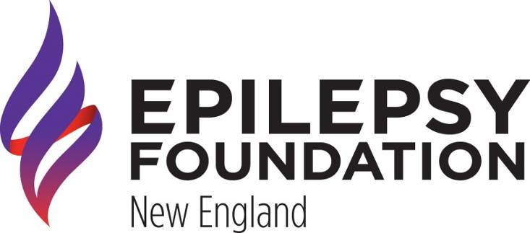 Presented by Susan Welby

Seizure Training
September 11, 2017
12:30pm-2:00 PM
Conant Community Health Center
5 Wally Krueger Way, Suite 6
Bridgewater, MA 02324

Registration by September 7th, please at Maureen.King@MassMail.State.Ma.Us
Please provide two-week notice for reasonable accommodations.

Parking is available to the right of the building for employees and short term visitors. For program participants, please drive past the Conant Center on Wally Krueger Way and park in the gravel lot to the RIGHT of the Senior Center.

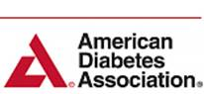
Diabetes Training
Presented by: Rev. Albert Whitaker, M.A. Northeast Region Director Community Health Strategies
October 3, 2017
10:00 am – 12:00 pm
Conant Community Health Center 5 Wally Krueger Way, Suite 6 Bridgewater, MA 02324

Registration by September 25, 2017 at raquel.pereira@MassMail.State.MA.US
Please provide two-week notice for reasonable accommodations.

Parking is available to the right of the building for employees and short term visitors. For program participants, please drive past the Conant Center on Wally Krueger Way and park in the gravel lot to the RIGHT of the Senior Center.

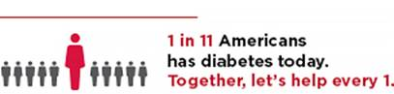

Pathways to
“The Good Things in Life”

A Practical Workshop on Assisting People
to have a Rich and Meaningful Life

October 30 & 31, 2017
9:00 am – 5:00 pm day one and 9:00 am – 3:00pm day two
Registration Fee $50 – includes lunch for 2 days

Central Congregational Church
2 Webster Street
Middleboro, MA

Pathways to

Valued roles are the pathway to the good things in life; things like
acceptance and belonging, abiding relationships, a positive self-image,
opportunity and experience, growth and learning.
For many devalued people, the forces of social devaluation prevent them from having access to valued roles as well as the “the good things in life.”

This workshop explores the importance of helping people fill valued roles in the face of vulnerability. Several tools (identity, culturally valued analogue, and a vision of valued roles) are offered to participants via short presentations, followed by facilitated small group work to use the ideas and craft a plan to move forward in the life of one person. Each prepares for the work ahead of time by learning about one person they serve or know, with permission, and brings that knowledge to fully participate in an action planning process.
This workshop will be an excellent brief introduction to Social Role Valorization, in advance of attending a full four-day SRV workshop. For graduates of the full four-day SRV workshop, “Pathways” works very constructively to explore implementation of valued roles for one person.

Come prepared to think and plan on behalf of someone you support – or better yet, come as a team ready to create change together!

ABOUT THE PRESENTERS:
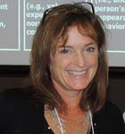
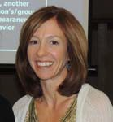
Betsy Neuville has served as the Executive Director of The Keystone Institute for well over a decade. She has over 25 years of experience within Keystone as a human service worker, administrator, agency director, evaluator, educator and personal advocate. She has extensive experience designing and developing supports for very vulnerable people. Betsy has worked extensively with the ideas of Normalization and Social Role Valorization and provides a great deal of training and consultation nationally and internationally.

Pam Seetoo has worked to assist people to live rich, full community lives for over 20 years. Over the course of her life's work, she has assisted people to leave institutions and establish themselves in the communities, supported children and families within foster care and host home programs, provides service leadership, and focuses on values-based education and facilitation.

REGISTRATION INFORMATION:
To register please contact Amy Cornell at The Nemasket Group
508-999-4436
amycornell@nemasketgroup.org
Scholarships available for individuals/family members

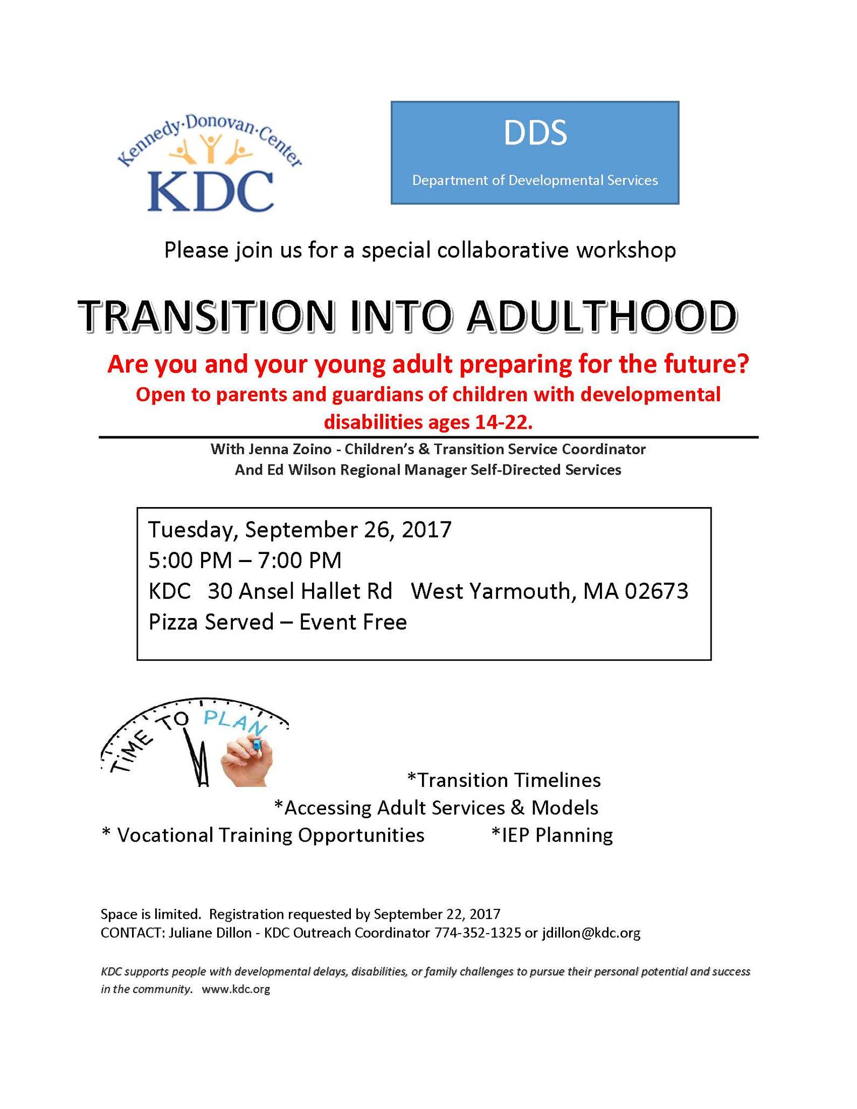
Plymouth Planning Committee is pleased to offer a training series….
PBS: Empowering Staff in Developing Person-Centered Supports
This series is aligned with the principles of Positive Behavioral Supports (PBS)
Facilitated by:
Michele Kissinger, Ph.D., BCBA Plymouth AO Behavioral Consultant
Maureen King, Learning and Development and Kyle Grace, Emergency Supports

Location: Plymouth Area Office,*shared conference room

September 20, 2017 9:30AM-12PM
Visual & Environmental Supports
This training will focus on an array of visual supports in relation to PBS universal supports and utilizing appropriate visuals as well as other environmental supports. In addition, part of the training will include an opportunity to work on visuals supports for specific individuals served by the participants.

October 18, 2017 9:30AM-12PM
Taking Accurate and Meaningful Data
This training opportunity will review types of data collection and when to use each depending on specific behaviors and goals of the individual. It will also include examples and methods to streamline data collection so it can be done in a staff-friendly yet effective way.

November 16, 2017 9:30AM-12PM
PBS and Person-Centered Planning that includes Cultural Sensitivity
This training will focus on creating a meaningful and person-centered plan in three parts:
- Identifying what is important to the person in order to live a meaningful life, including one’s culture, values, hopes, dreams, and lifestyle choices, etc.
- Supporting the person to create a vision, and short and long term goals to fulfill their vision, based on what was found to be important to them.
- Creating PBS Universal Supports and strategies that facilitate the accomplishment of the person’s goals and vision in balance with safety and living a life that is meaningful to them.
Please register with Denise Kelliher at denise.kelliher@state.ma.us
These trainings are offered as a series. However, it is not required that you attend all three.

Space is limited to 20 people
Please provide 2-week notice when requesting accommodations. Thank you!

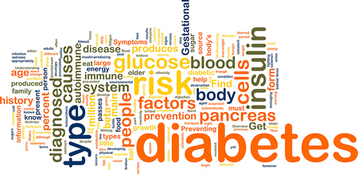
The Fall River Training Committee will be offering another session of the diabetes support and information group/diabetes management group which incorporates sessions involving nutrition games, cooking demos and general diabetes management.
This is not offered only to people with diabetes. Anyone interested in preventing diabetes or that is prediabetic, is welcome and encouraged to attend.
This training is appropriate for the individual’s that we support, family, friends and caregivers.

When: September 20th at 3PM (We meet the third Wednesday every month)
Where: DDS Fall River, 1 Father DeValles Blvd.

Please register with Anna Viveiros
AnnaM.Viveiros@State.MA.US or 508-730-1209/VOIP 2001038
Please pass this information on to anyone that you feel may be interested in attending this group.

At the first meeting, the group expressed an interest in meeting every month .We will offer this every month as long as there is enough interested. New participants are always welcome.

*COMPLAINT PROCESS*
People with disabilities are one of the most vulnerable populations. The Commonwealth of Massachusetts safeguards these individuals in many ways, one of which is a partnership between the DDS and the DPPC. This training will describe the complaint review and resolution process when there are suspicions of abuse or neglect of people served by the Department.

Presenters:
Susan Love, Abuse Prevention & Outreach Coordinator DPPC
Tom MacDonald, Senior Investigator DDS Southeast Region
Jennifer Chaves, Program Monitor, DDS Fall River Area Office

Friday, October 27, 2017
10:00 am – 12:00 pm
Southeast Regional Office
151 Campanelli Drive
Middleboro, MA



Register with: Raquel.Pereira@massmail.state.ma.us
BE A BETTER. . .
healthy meal planner
How to reinforce & support Executive Order 509 by building effective meal planning skills.
Goals for this Training:
• Learn how to easily apply Executive Order 509 to meal planning
• Learn how to create weekly menus that are healthy, fuss free and work within your home’s budget and busy schedule
• Learn how to incorporate those you serve in this critical process
• Learn tips and tricks of what to say or do at the grocery store, home or meals out to redirect others towards healthier alternatives



Date: Friday, October 20th, 2017
Time: 1:00 pm to 3:00 pm
Place: Conant Community Health Center
5 Wally Krueger Way – Bridgewater

This training is ideal for direct support professionals, advocates, managers, nursing staff, meal planners and grocery shoppers within the homes to learn many creative ways to keep Executive Order 509’s Nutrition Standards intact through building effective meal planning skills. Susannah Locketti, owner of Well Adapted Trainings is a nationally recognized meal planning expert and trainer with over a decade of human service experience creating and implementing wellness initiatives. Her fun, relatable and user-friendly approach makes for a user-friendly training staff can relate to. Registration information is below and Nursing CEU’s are available. We hope you’ll join us!

Please Register with: Raquel.Pereira@massmail.state.ma.us

IMPORTANT PARKING INFO CONANT COMMUNITY HEALTH CENTER AT 5 WALLY KRUEGER WAY, BRIDGEWATER
Wally Krueger Way is located just one mile south of Bridgewater Center between Barrett’s Alehouse and Signature Healthcare on Routes 18/28. The Conant Community Health Center is the first building you come to as you turn onto Wally Krueger Way from Routes18/28. Parking is available to the right of the building for employees and short term visitors only. Program participants, please drive past the Conant Center on Wally Krueger Way and park in the gravel lot to the RIGHT of the Senior Center.

Train the Trainer Project:
Human Guide & Vision Loss Sensitivity

September 22nd 2017 9:00am – 3:00pm Waltham, MA

Applications Due: September 18th 2017, Space is limited to 10 participants
Application Form: Please download from our website (open in Google Chrome to best view all site features): http://www.focusonvisionandvisionloss.org/train-the-trainer.html

About:
Train the Trainer Project for Human Guide & Vision Loss Sensitivity is a collaborative program presented by the Massachusetts Department of Developmental Services (DDS) and the Massachusetts Commission for the Blind (MCB). The goals of the Project are to strengthen outreach re: Human Guide (formerly known as Sighted Guide) and Vision Loss Sensitivity to co-workers at the agency where the trainer is employed:

Colleague to colleague training for new staff and/or
Refresher training for existing supervisors and staff

How it Works:
Selected trainers will spend a 6 hour session (inclusive of lunch and breaks) with our team of Certified Orientation & Mobility Specialists. Activities will include lecture, experience as a presenter; and sitting, walking and being guided while wearing a blindfold. At the end of the session* each trainer will receive all of the materials, including a training agenda, “Let’s Walk Together” video, handouts, occluders, attendance forms, etc. needed to conduct small group in-services on Human Guide & Vision Loss Sensitivity. *Each candidate must meet specific requirements, including the passing of a multiple choice test, in order to receive the above materials, and the certificate of completion.

Collaboration & Follow–Up:
Trainers will receive ongoing support, including an invitation to attend an annual meeting with fellow Human Guide & Vision Loss Sensitivity (HGVLS) trainers from across each DDS Region.

Benefits for All:
Individuals with Vision Loss:
Enhance personal safety and quality of life by working with staff and caregivers sensitive to unique needs of living with a vision loss.

Residential/Day/Employment Providers:
Increase the skill set of employees regarding working with individuals who have vision loss.

Trainers:
Increase personal knowledge regarding Human Guide Technique and Vision Loss Sensitivity;
Enhance presentation skills
Become part of a Regional collaborative team
Gain opportunity to support co-workers in a unique way

Requirements:
Candidates for the Train the Trainer Project must agree to the following:
Attend a 6 hour session (inclusive of lunch and breaks) that includes lecture, blindfold experience, and multiple choice test.
Wear appropriate footwear, comfortable clothing, and dress for the weather as there is an outdoor portion of the training.
Conduct 45-60 minute HGVLS trainings at his/her agency according to agency training needs. An annual “refresher” HGVLS training is recommended for all staff at an agency.
Prepare all necessary paperwork: sign in sheets, evaluation forms prior to each training and send copies of all sign-in sheets and evaluation forms to MCB/DDS Partnership Project contact after each HGVLS training conducted at his/her agency.
Notify MCB/DDS contact if the Trainer leaves the agency.

How to Apply:
1. Download the application from our website:
http://www.focusonvisionandvisionloss.org/train-the-trainer.html
2. Please fill the application out completely.
3. Send completed application back by September 18th 2017 (contact information is provided on the form).
4. You will receive confirmation via email of either your seat OR a notice that the session is full*.

*Please Note: Space is limited to the first ten applications. Approval from both an employee’s direct supervisor and agency director is required prior to applying.

Applications due by: September 18th 2017 / Space Limited to 10 applicants

Training Locations and Dates:
Metro Region: September 22nd 2017
Location: DDS Metro Region
Large Conference Room
465 Waverly Oaks Road,Suite 120
Waltham, MA 02452

ARE YOU LOOKING FOR
ON-SITE WATER SAFETY TRAINERS TO COME TO YOUR AGENCY?
Contact:
Well Adapted Water Safety Training
Email: welladaptedtrainings@gmail.com

Well Adapted is an approved vendor for the Commonwealth specializing in on-site water safety trainings for human service professionals. We offer 11 years of direct human service experience working with swimmers of varying abilities combined with 15 years of water safety experience for special populations including the developmentally disabled, autistic, visually/hearing impaired, swimmers with traumatic brain injury and physical disabilities. Our two hour training meets the DDS Water Safety training requirement for agencies attending lifeguarded locations.

BENEFITS OF ON-SITE TRAINING?
☑ Cost effective to train staff all at once.
☑ Reduces agency costs by eliminating employee travel which adds up!
☑ Training can be tailored to your agency needs.
☑ Pick a time that works for YOU! We train on Mondays anytime!
☑ Staff only need to take it once-it is a one and done!

We train on-site for an agency minimum of *15 employees.
(*You can invite other agencies to meet the minimum number.)
Cost per person varies based on where your agency is located.
South Shore of MA: $40 per person (minimum 15 people)
Cape & Islands/Boston/Central/Western MA: $75per person (minimum 15 people)

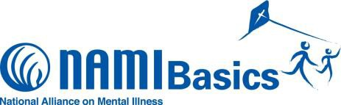

What is the NAMI Basics Education Program?

NAMI Basics is a free, six-session program designed for parents and other family caregivers of children and adolescents with emotional and behavioral difficulties. NAMI Basics helps parents and other family caregivers of children to understand the illnesses that are causing those behavioral difficulties, and the critical role families play in the treatment of those illnesses. The program is taught by trained teachers who are also the parents or family caregivers of individuals who experienced emotional or behavioral difficulties prior to age 13. This “Basics Class” is being provided through a grant from South Shore Comm. Partners in Prevention – CHNA23

NAMI PLYMOUTH AREA, the local organization of the National Alliance on Mental Illness, will offer its NAMI Basics Education Program this coming FALL for 6 consecutive Mondays, beginning September 18th,2017. CALL FOR INFORMATION AND TO REGISTER.

Participant Perspectives
“This is such a great step by step program that walks
parents every step of the way. It is as if you are
holding their hand through it all.”

“The course is inclusive of almost all aspects of family and child resources. I could have spent a lifetime getting all this information on my own. I feel supported, strong and ready to go forward.”

“NAMI Basics bridges the gap. It provides help that can’t be found in a doctor’s office.”

Contact us to register for this NAMI Basics class! REGISTRATION IS A MUST!

Six weeks beginning September 18th (7pm-9:30 pm) at BID-Plymouth. Registration is a must.
TO REGISTER call: 508-209-1124

About NAMI



KATHLEEN CONSIDINE NAMI PLYMOUTH AREA 508-209-1124
kconsid@att.net

NAMI, the National Alliance on Mental Illness, is the nation’s largest grassroots mental health organization dedicated to building better lives for the millions of Americans affected
by mental illness. NAMI Plymouth Area is an affiliate of
NAMI Mass. NAMI Plymouth Area and dedicated volunteer members and leaders work tirelessly to raise awareness and provide essential education, advocacy and support group programs for people in our community living with mental illness and their loved ones.

What is the Participant-Directed Program Model?
Participant-Directed Model?
(continued)

Choosing Which Service Method is Best for You



The Participant Directed Program (PDP) offers the most flexibility to arrange and customize supports based on the individual’s needs and preferences. The individual can hire their own support staff and make other decisions about how to use their DDS funded allocation.

In the Participant Directed model:
The person self-directing makes his or her own decisions, determines how their DDS funding is spent for services, supports and goods (within DDS guidelines), and takes responsibility for the decisions he or she makes.
A fiscal intermediary (FI) serves as the agent for individuals and families and is responsible for all payments. The FI pays for support staff, and other goods and services in accordance with the participants’ budget. The FI provides financial monitoring and reporting and ensures compliance with all applicable federal and state laws, DDS and other state agency regulations, and with other DDS requirements.

A Support Broker, typically a DDS Service Coordinator, helps the person define his or her needs and dreams through a person centered planning process that leads to an Individual Service Plan (ISP). The Support Broker helps the individual create and manage a budget within the allocated resources, and develop a network of services/supports.

The Support Broker also acts on behalf
of the individual to arrange for needed services, provides information on resources supports the individual in evaluating the effectiveness of supports.
The Individual Budget is a mechanism that enables a participant to direct and manage the delivery of services he or she chooses to use.
By utilizing the budget an individual has:
- control of a specific amount of funds and
- the responsibility and freedom to purchase supports, goods and services from a variety of sources.
DDS completes the process to qualify staff hired by the individual. All staff employed in this model must:
- be at least 18 years old
- have a CORI (Criminal Offender Record Information)
- have a high school diploma or GED Certificate

Your Area Office can provide you with additional information about these service model options. Also, see the DDS website at: www.mass.gov/dds.

Rev. 03.16

The
Commonwealth of
Massachusetts

Executive Office of
Health and Human Services

Department of
Developmental Services

Types of Service Delivery Models
What is the
Agency with Choice Model?
The Agency with Choice model allows individuals and families to choose and supervise their staff and to purchase goods and services, without having to be responsible for regulatory, accounting, legal and technical duties associated with being an employer and purchaser.

In this model:
The individual/family AND the provider agency are responsible for hiring the staff, for all duties of an employer, and for appropriate purchasing of all other goods and services. The provider manages certain aspects of the budget to ensure compliance with applicable federal and state laws, DDS and other state agency regulations, and other DDS requirements.

The individual/family selects the employees made available through the agency, sets work hours and tasks to be performed, provides daily supervision and management of employees, and determines when that staff person is no longer needed.

The agency and individual/family share in training and evaluating employees.

DDS offers three models of service delivery that allow people receiving services to have choices about how their services are provided.

DDS has developed service delivery options that offer people more decision making and control regarding what services they need (and don't need) and how the services can be provided to best help them.



- The Traditional Model
- The Agency with Choice Model
- The Participant Directed Model

The Traditional Model is the most commonly used model in Massachusetts.
In this model:



In this model:
The provider agency (qualified and licensed) contracts directly with DDS to deliver a specific range of supports (e.g. shared-living, community residences, independent supports, employment and day programs, family support) to the individual.

The agency has full authority and responsibility for hiring, training, supervising and paying employees.

The individuals, their families and service teams develop Individual Service Plans (ISP) and provide input on other day to day decisions.

The provider agency has the responsibility for managing all aspects of the budget so that the services and ISP are provided according to applicable federal and state laws, DDS and other state regulations, as well as other DDS requirements.

What is the
Traditional Model?

BUILD A BETTER LUNCH
How to reinforce & support Executive Order 509 when making or planning for lunchtime.


Goals for this Training:
• Learn how to apply Executive Order 509 to lunchtime meals & snacks
• Learn how to create a healthy lunch someone will not pass up!
• Learn how to incorporate individuals in the lunch making process
• Learn how to reduce choking risks at lunchtime through thoughtful lunch preparation.

Date: Friday, October 13, 2017
Time: 1:00 pm to 3:00 pm
Place: Conant Community Health Center
5 Wally Krueger Way – Bridgewater, MA

This training is ideal for direct support professionals, advocates, managers, nursing or recreation staff to learn many creative ways to keep Executive Order 509’s Nutrition Standards intact. Susannah Locketti, owner of Well Adapted Trainings is a nationally recognized meal planning expert and trainer with over a decade of human service experience creating and implementing wellness initiatives. Her fun, relatable and user-friendly approach makes for a user-friendly training staff can relate to. Registration information is below and Nursing CEU’s are available. We hope you’ll join us!

Please Register with: Raquel.Pereira@massmail.state.ma.us

IMPORTANT PARKING INFO
CONANT COMMUNITY HEALTH CENTER AT 5 WALLY KRUEGER WAY IN BRIDGEWATER, MA

Wally Krueger Way is located just one mile south of Bridgewater Center between Barrett’s Alehouse and Signature Healthcare on Routes 18/28. The Conant Community Health Center is the first building you come to as you turn onto Wally Krueger Way from Routes18/28. Parking is available to the right of the building for employees and short term visitors only. Program participants, please drive past the Conant Center on Wally Krueger Way and park in the gravel lot to the RIGHT of the Senior Center.

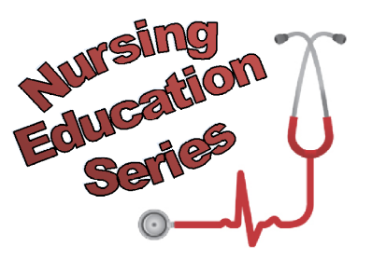
Falls Prevention Training

Gregory M. Stelmach, OTR/L
Managing Director
www.VisitingRehabServices.com

October 20, 2017

10:00 am – 12:00 pm

Conant Community Health Center
5 Wally Krueger way, Suite 6
Bridgewater, MA 02324

Registration by October 13, 2017 to raquel.pereira@state.ma.us
Please provide two-week notice for reasonable accommodations.



Parking is available to the right of the building for employees and short term visitors. For program participants, please drive past the Conant Center on Wally Krueger Way and park in the gravel lot to the RIGHT of the Senior Center.

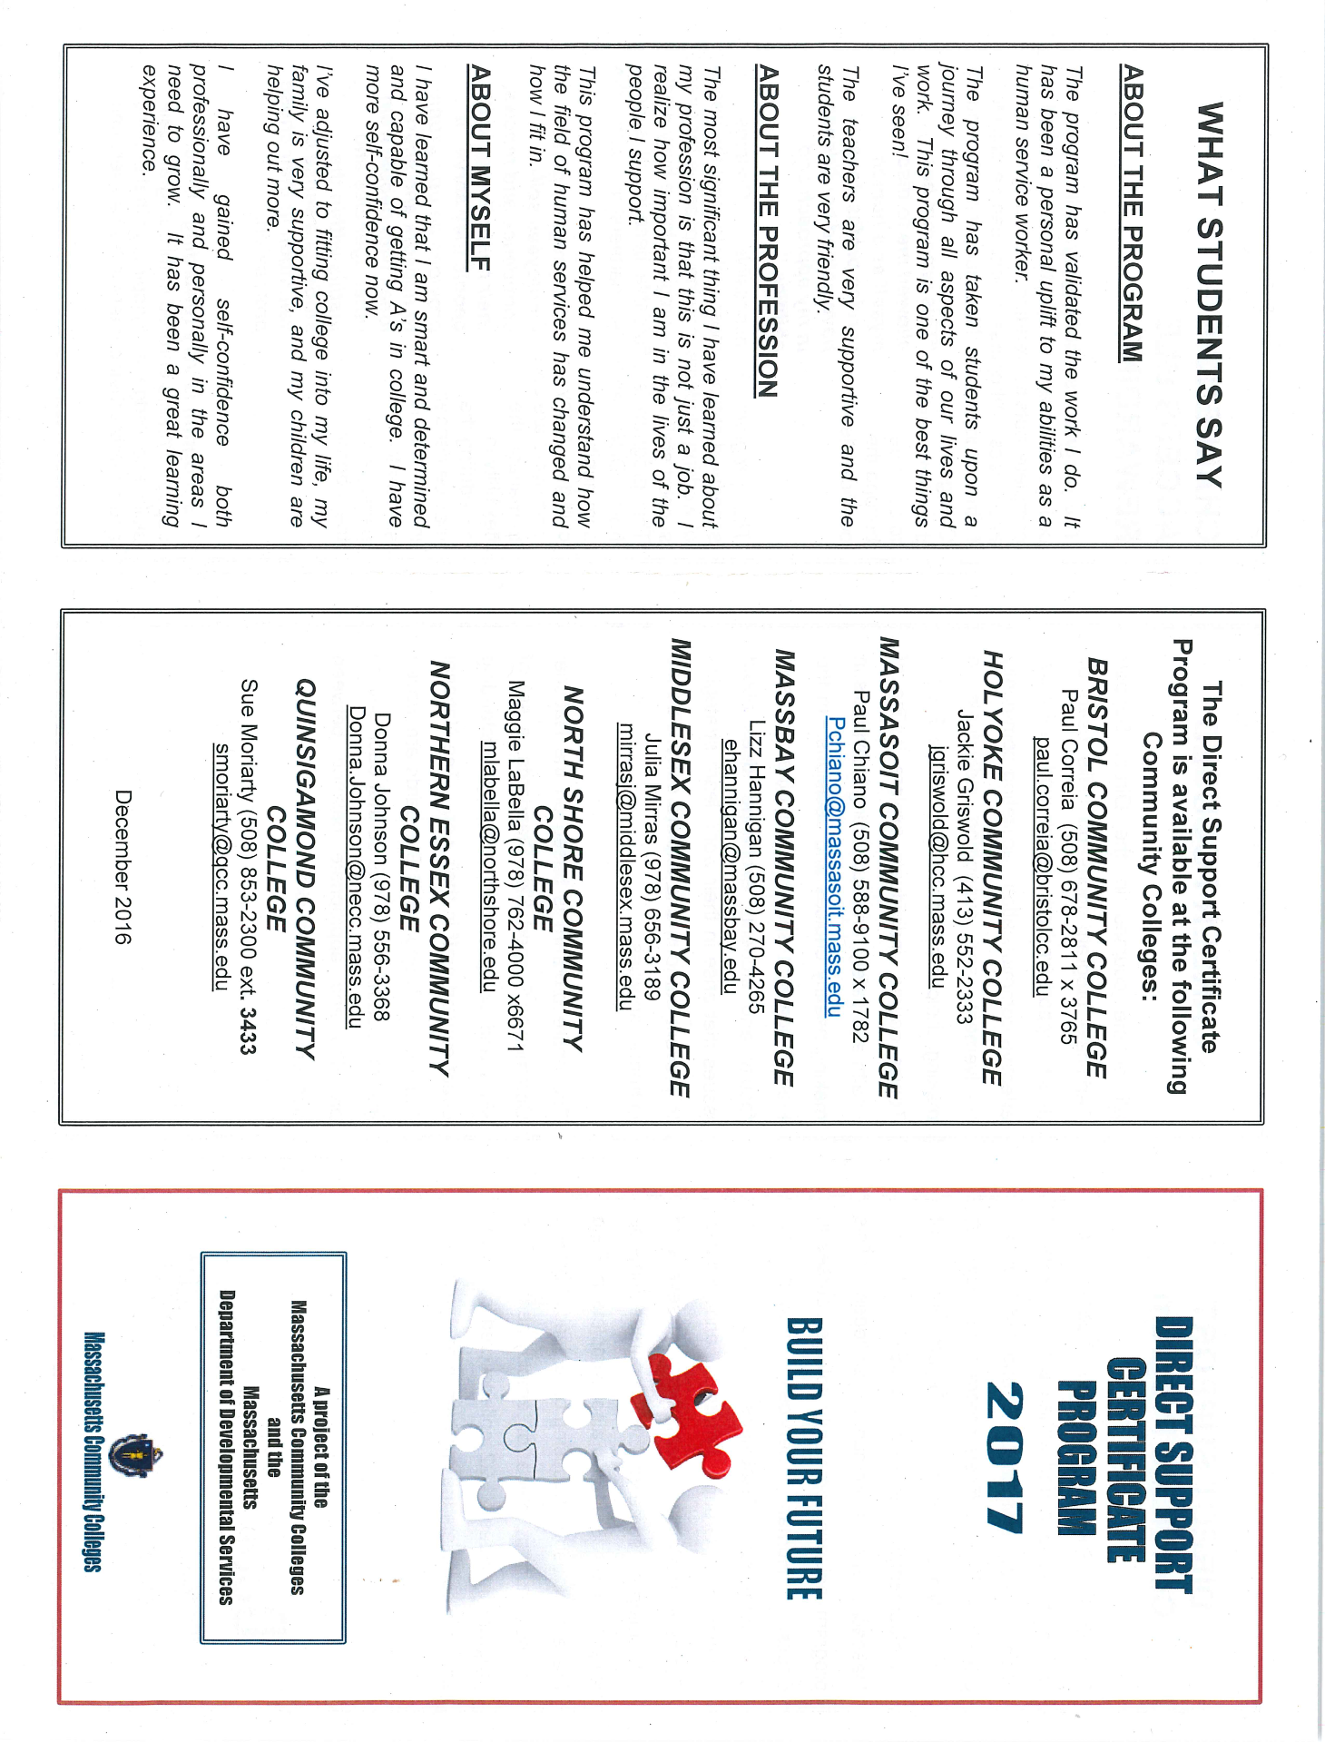
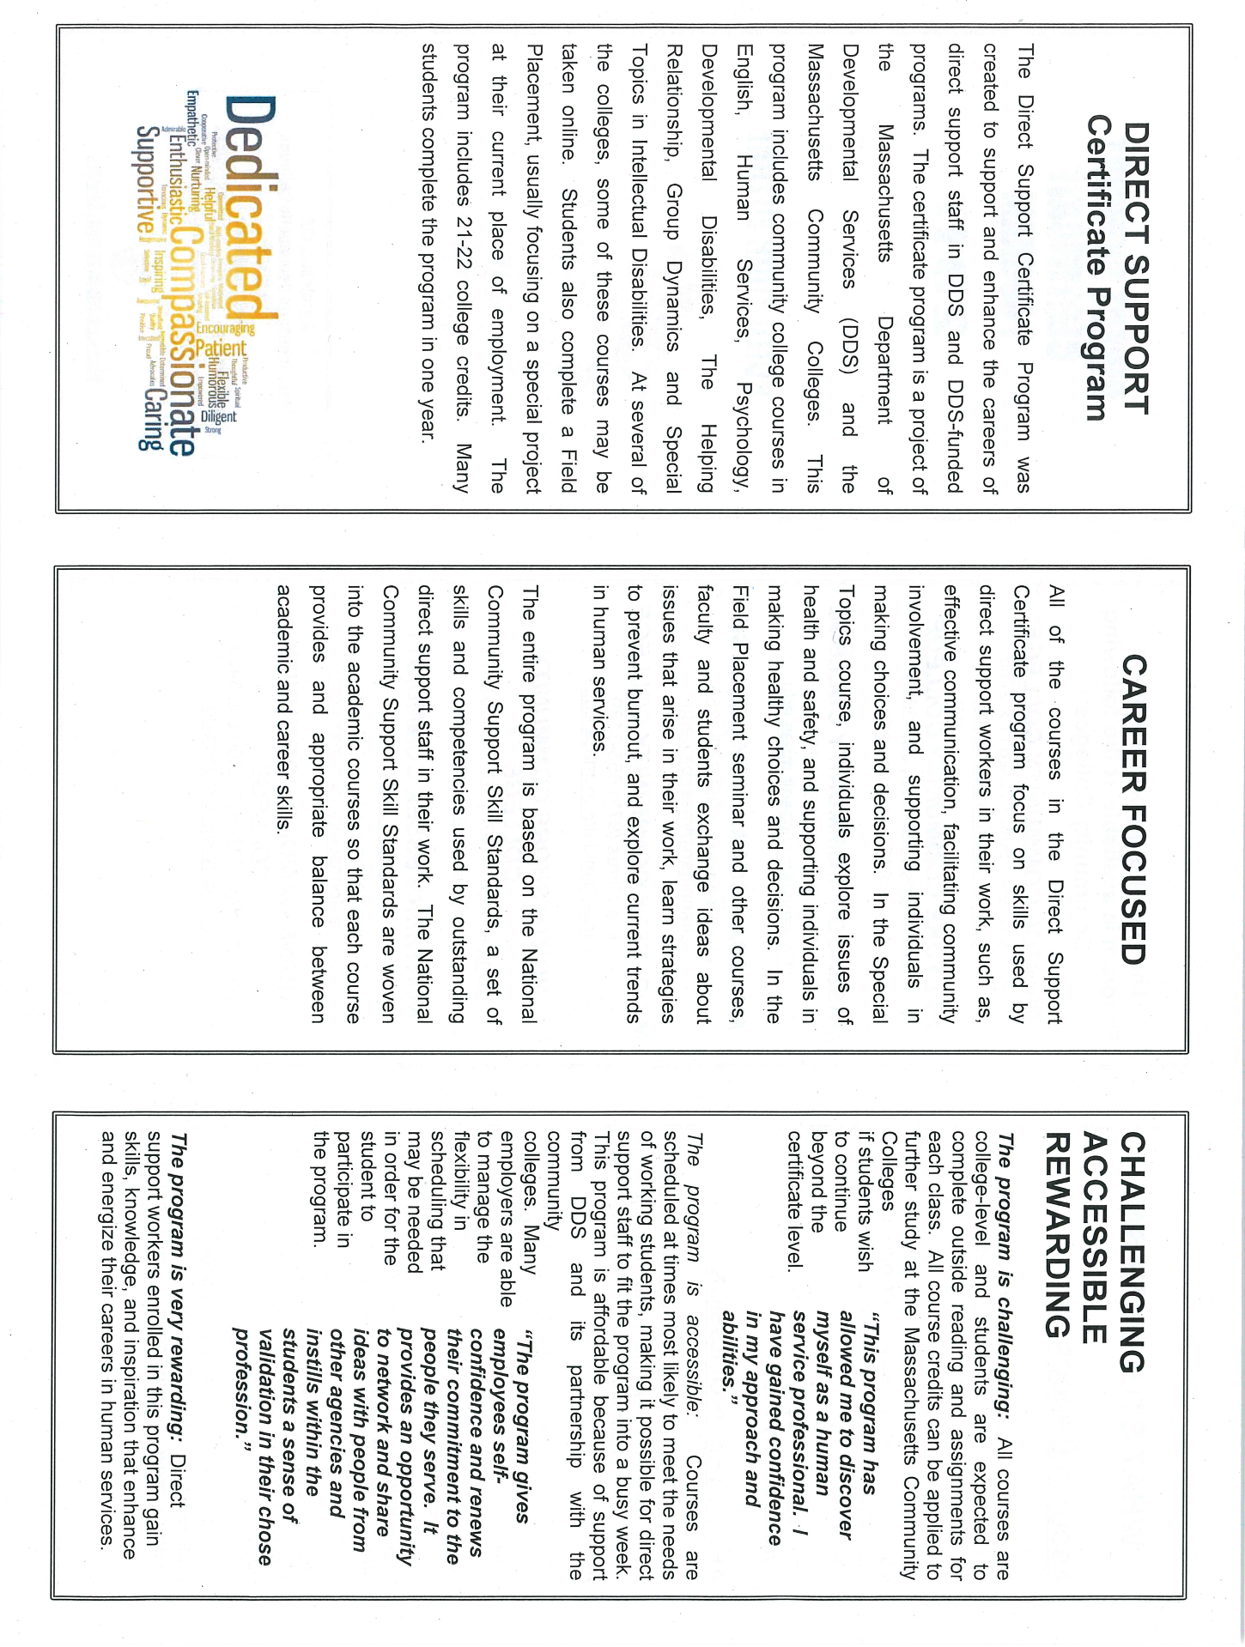

Please join us for a training presentation on Diabetes CEUs will be offered

Presented by:
Lisa Cordeiro, RN, BSN, CDE
Coordinator, Diabetes Education Program
BI Deaconess Hospital – Plymouth

October 27, 2017
10:00AM- 2:00PM
Conant Community Health Center
5 Wally Krueger Way, Suite 6
Bridgewater, MA 02324

Please RSVP: raquel.pereira@state.ma.us
Please provide two-week notice when accommodations are requested

Diabetes overview (Type 1, Type 2, Gestational)
Diagnosing diabetes
Acute and Chronic complications (signs, symptoms, treatment & prevention)
Blood glucose testing, including target glucose numbers
BP, Cholesterol related to diabetes management
Nutrition (carbohydrate management and portion control)
Medications (risks, benefits, oral, non-insulin injectable, insulin)


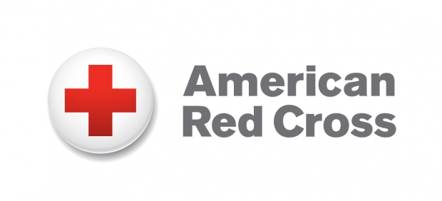

Water Safety Today
Come join American Red Cross Certified Water Safety Instructor
Patrick Raymond for a 2 hour Water Safety Today certification course. This
certification meets the DDS water safety training requirement and includes
considerations for special populations in an aquatic setting. After
completing this course participants will receive a lifetime certification from the
American Red Cross and will be able to prevent, recognize and respond to emergencies in, on and around the water. *An optional in-water training to further enhance safety skills is available in our heated therapeutic pool. Participants will learn to perform basic reaching, throwing and wading assists to best support swimmers and provide the highest level of safety in the water.

*This is not a lifeguarding course.
Date: October 18th Time: 1:30-3:30 Optional in water time: 3:30-4:00

Offered By...
NEW ENGLAND VILLAGE, INC.
Complete the required information, detach and mail to the address below with a check payable to New England Village.

AGENCY NAME: _________________________________________ CONTACT PERSON: _____________________________

CONTACT PHONE NUMBER: _____________________________________________________________________________
Names of Registrant(s): (PLEASE write legibly) In Water Add-On (Additional $25 per person)
1.) _______________________________________________________  Yes  No
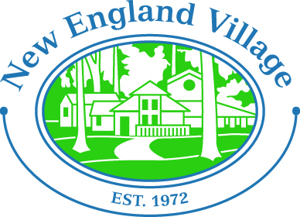
2.) _______________________________________________________  Yes  No
3.) _______________________________________________________  Yes  No
4.) _______________________________________________________  Yes  No
5.) _______________________________________________________  Yes  No
6.) _______________________________________________________  Yes  No
Total # of Attendees: __________ X  Individual Rate ($40 per person) or  Group Rate ($35 per person for 6 or more)
Total # of In-Water Attendees: __________ X  Add’l $25 per person (Must take Water Safety Today to attend)
TOTAL $ ENCLOSED: _________

MAIL TO: Patrick Raymond c/o New England Village 664 School Street, Pembroke, MA 02359
REGISTRATIONS MUST BE RECEIVED BY 10/9/17 TO ATTEND THE TRAINING. DROP-INS WILL BE TURNED AWAY.


Food for Health
To ensure healthy meals and snacks are provided to your clients and patients, Executive Order 509 requires impacted state agencies to follow the MA Nutrition Standards. If your agency buys or prepares food for your clients on a daily basis, you can participate. (And, you might even learn something to improve your own health!)
Free Online Course
for
Massachusetts State Agencies

Learn new ways to purchase and prepare healthy food

• FREE 5-module course for Massachusetts staff who buy or prepare food.
• Each module takes about 30 minutes to complete.
• You will receive a certificate upon completion.
• Speak to your supervisor if you have any questions.
To register, send an email to dph@framingham.edu with the following information:
- Your email address
- Your organization
Developed by Framingham State University for the Massachusetts Department of Public Health

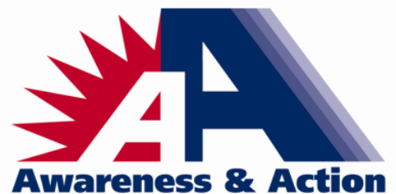

Awareness & Action

Training

This FREE training, taught by persons with disabilities and others,
is designed to educate persons with disabilities and others about recognizing, reporting and responding to abuse.

If you are interested in having an
Awareness & Action Training at your
organization, please contact:
Anne Monti at

Anne.Monti@state.ma.us

Phone: 1-617-727-6465 x234

The training is three hours long, intended for everyone
and limited for up to 20 people.
Sexual Abuse
Neglect
Verbal Abuse
Financial Abuse
Physical Abuse







MASSACHUSETTS ADVOCATES STANDING STRONG

M.A.S.S. would like to work with providers, DDS staff, family organizations, self-advocacy groups, and community
groups to offer training on the following topics:

- Self Determination and Choice
- Self Advocacy- What It Is? How to Start a Local Group? Leadership!
- New Staff Orientation
- How to Be an Effective Board Member
- Design a training with you to meet your needs

M.A.S.S. is a statewide self-advocacy organization started and operated by individuals with cognitive or
developmental disabilities. We work with local self-advocacy groups across the Commonwealth. We know that
our voice is stronger when we work with people who have the same beliefs and values as we do.
Our Mission: To empower self advocates through education so we make choices that improve and enrich our lives.
Some of our most recent work has been:
- Self Advocacy Leadership Series with MDDC taught by self advocates and their advisors
- Tools for Tomorrow Project with ARCMASS, Families Organizing for Change, and MDDC to help people achieve their hopes and dreams. Access Living of Chicago to teach self advocates about housing options
- The Bridges Project with DMR, Central Mass Self Advocacy Workteam, and Worcester ARC to support people moving out of nursing homes
- Active participants on the federally funded Real Choices Project

We can be reached at:
Phone: 1 866 IAM-ABLE (1 866 426-2253)
Email: mass1998@earthlink.net
Address: PO Box 6025
N. Plymouth, MA 02362
Website: http://www.Massadvocatesstandingstrong.org

“Nothing about us without us.”



Do you sometimes think that no one understands what you are feeling?

Do you wonder if you’re the only one who has these feelings?

Do you wish you had some friends who felt the same way that you do?

Think about joining the
Rainbow Support Group of Massachusetts!
The Rainbow Support Group provides support and information to individuals with intellectual challenges who are gay, lesbian, bisexual, transgendered, cross-dressers or are questioning their sexuality. Meetings give you the chance to talk about your sexual interests with other people who are trying to be comfortable and happy about their sexuality.

We are now in the process of starting groups in all five regions of the self advocacy organization, Massachusetts Advocates Standing Strong.

- Contact us to learn more and find out if there is a Rainbow Support Group in your area. Agencies can contact us if you are interested in sponsoring a Rainbow Support Group.

For additional information - Please call Pauline Bosma – Program Coordinator at 508-944-5797 or e-mail her at (rainbowbos@charter.net) or e-mail MASS Advocates Standing Strong at mass.office.info@gmail.co .

AGING AND DOWN SYNDROME
A HEALTH & WELL-BEING GUIDEBOOK
Lead author: Julie Moran, DO
Sponsoring Organization: National Down Syndrome Society

“Adults with Down syndrome, along with their families and caregivers, need accurate information and education about what to anticipate as a part of growing older, so they can set the stage for successful aging.”

To receive a free copy of the guidebook go to: www.ndss.org- in the search box type in aging and down syndrome- available online and in print- available in English and Spanish

THE IMPORTANCE OF BELONGING
David Pitonyak
“ In my view, most people served by the human service industry are profoundly lonely. :loneliness is the central reason why so many are unhappy and distraught….Their suffering results from isolation…Loneliness is the only real disability…wake up to the people right next to you…help the person to make a contribution to the broader community…”

To receive a of this booklet go to: www.dimagine.com – click on articles/publications- available in English and Spanish
_____________________________________________________________________________



Getting Ready For An Emergency
Emergencies like floods, storms or pandemic flu can happen to lots of people at once.
Be prepared so you know what to do!
Would your group like a free emergency preparedness training?
Self-advocate Nate Trull trains consumers and support staff about getting ready for emergencies. He has trained over 100 people in Massachusetts.

He can train your group in two ways:

(1) a two part training where each part takes about an hour and a half on two different days; or

(2) a one-time training that takes about two hours. There is no cost for the training, but your group will need to provide a room, a screen or wall for a PowerPoint® presentation, a power point projector, and an audience. People who come to the workshop will get presentation handouts, a folder of information, and consumers will receive small items to start their own supply kits.

For More Info Contact: Nate Trull at nate.trull@comcast.net

Family Support Centers

Family Support Centers across the state, funded by the Department of
Developmental Services (DDS), provide information, assistance, and a
variety of supportive services to families with children and adults with
intellectual and developmental disabilities who are living at home.
These services include:

- Providing information and assistance in obtaining a wide array of services including but not limited to:
  - Social and recreational opportunities
  - Support groups for parents, siblings and family members
  - Resources in the community
  - Public benefits

- Hosting trainings or providing information on topics such as:
  - Guardianship/Trusts
  - Planning for the Future
  - Social Skills
  - Human Relationships
  - Specific disabilities and/or conditions

- Offering opportunities for families to meet through networking and
organized social and community activities

Families who are eligible for services from DDS are encouraged to contact one
of the Family Support Centers near them. The Family Support Centers in the
Southeast Region are included here. A directory with the contact information
for all Statewide Centers is available on the DDS web-site at www.mass.gov/dds.

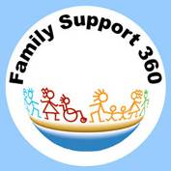

FAMILY SUPPORT CENTERS
Funded by the Department of Developmental Services

SOUTHEAST REGION

Brockton Area
Brockton Area Arc
1250 West Chestnut Street, Brockton, MA 02301
(508) 583-8030, x224
Kathy Kerwin - kkerwin@brocktonarc.net
www.brocktonareaarc.org

Cape Cod and the Islands Area
Kennedy-Donovan Center
32 Commercial Street, South Yarmouth, MA 02664
(508) 385-6019
Dan Sprout - dsprout@kdc.org - Laura Griswold - lgriswold@kdc.org
www.kdc.org

Martha’s Vineyard Community Services
111 Edgartown Road, Vineyard Haven, MA 02568
(508) 693-7900
Kathi Hackett, x249 - KHackett@mvcommunityservices.com
Sharon Clauss-Zanger - Sclauss-zanger@mvcommunityservices.com
www.mvcommunityservices.com

Fall River Area
People Inc.
FACE Center (Family Advocacy and Community Education Center)
4 South Main Street, Fall River, MA 02721
(508) 672-5671
Marilyn Grubb - mgrubb@peopleinc-fr.org
Jason Medeiros (774) 488-5321 Jmedeiros@peopleinc-fr.org

New Bedford Area
Nemasket
Family Connections Center, Nemasket
107 – 109 Fairhaven Road, Mattapoisett, MA 02739
(508) 999-4436
Sandra Kinney - sandykinneyfc@nemasketgroup.org
Emily Nisenbaum - tngemily@aol.com
www.nemasketgroup.org

Plymouth Area
The Arc of Greater Plymouth
10 Cordage Park Circle, Suite 208, Plymouth, MA 02360
(508) 732-9292
Malissa Kenney - malissak@thearcofgp.com
Kristine Scigliano -kristines@thearcofgp.com
Kelly Newcomb - kellyn@thearcofgp.com

South Coastal Area
Advocates, Inc.
South Coastal Family Support Center
1189 R North Main Street, Randolph, MA 02368
(781) 767-3048
Alicia Cannon - acannon@advocatesinc.org
Fatima Baptista - fbaptista@advocatesinc.org
http://southcoastalfamilysupport.org/

South Shore Support Services
317 Libbey Industrial Parkway- Unit B300, P.O. Box 890126, Weymouth, MA 02189
(781) 331-7878
Mary Burt, x13
Renee McCorkle, x19 - rmccorkle@southshoresupportservices.org
www.southshoresupportservices.com

Taunton/Attleboro Area
The Arc of Bristol County
146 Pleasant Street, Attleboro MA 02703 Mailing address: 141 Park Street
(508) 226-1445 x 3118
Beth Bogus - bbogus@arcnbc.org

Tri-Area (Brockton, Plymouth, South Coastal)
BAMSI
155 Webster Street- Unit D, Hanover, MA 02339
(781) 878-4074
Mary Ann Mills-Lassiter - Mmills-lassiter@bamsi.org
Sharon Craig - scraig@bamsi.org - familysupportcenter@bamsi.org www.bamsi.org

SAVE THE DATE!

September is Mitochondrial Disease Awareness Week is celebrated globally to educate ... Disease Awareness Week will be held September 17-23, 2017 ...put out your Green Lights

October is Disabilities Awareness Month.

October is Breast Cancer Awareness Month…put out your Pink Lights

Deaf Outreach, Support & Consultation (Work, Inc)

October 26, 2017 – Compassionate Conversations - 1:00 pm – 4:00 pm (Middleboro) – more info to come…



March 14, 2018

Please join us for the 13th annual
“Focus” on Vision Impairment and Blindness Conference

Meeting the Needs of Individuals with Intellectual Disability & Vision Loss

At the Four Points By Sheraton – Norwood, MA

May 10, 2018 - Nurses Conference

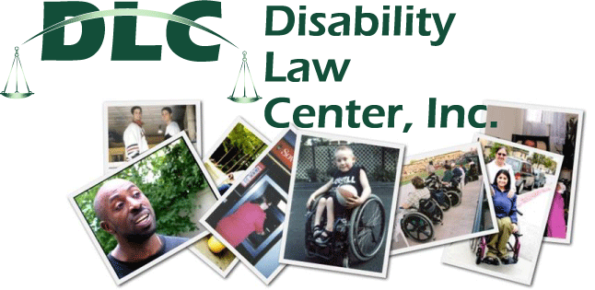
A private, non-profit public interest law firm
Disability Law Center provides legal advocacy on disability
issues that promote the rights of people with disabilities to
participate fully and equally in the social and economic life of
Massachusetts
Our office is accessible and is open
Monday through Friday, 9 A.M. to 5 P.M.
DLC can make arrangements for sign language and
foreign language interpreters or other accommodations
that you may need.
For More Information
http://dlc-ma.org
1-800-872-9992 voice
1-800-381-0577 TTY

SOUTHEAST MASSACHUSETTS FAMILY LEADERSHIP SERIES 26

The 26th SE Family Leadership Series is about to begin! The Series focuses on supporting families and individuals to live in their communities as naturally and typically as desired. Applications from families with children or adult family members of any age with any disability who are Department of Developmental Services eligible are encouraged.

The Family Leadership Series has a three-fold purpose. The first is to offer information about “best practices” for people with disabilities. The second is to assist families in creating a vision for their family member and a process to achieve the vision through leadership and advocacy. The third is to develop family leaders who will advocate at the local and state level to improve the lives of individuals with disabilities. The dates of the SE Family Leadership Series 26 are: October 27 & 28, 2017; January 19 & 20; March 9 & 10; and April 20 & 21, 2018. Each session is two days in length. Participants are required to attend all four sessions.

The Series:
Initiative and Leadership – family members are given information on the background of the family support movement, leadership, advocacy and the significance of self-advocacy, how to effectively advocate for change and ways to influence funding and delivery systems.
Creative, Progressive and Innovative Ways to Provide Support – how to help our family members and our families to live quality lives. A number of presenters offer their perspectives on a broad range of topics: Inclusion in schools; supported employment; positive practices; community living and family support.
Creating A Vision – families are supported to “imagine better” and to create a vision, with and for their family members, that guides their leadership and advocacy. What advocacy is necessary to ensure the visions that are developed and what is effective advocacy?
Policy Making at the Local, State and Federal Level – family members receive information on how to develop networks with professionals and families, how to access and control resources that affect family stress and satisfaction and how to use legislative change to procure resources.

Food and overnight lodging for each family at the Holiday Inn in Taunton is paid for by the Department of Developmental Services. Respite/childcare/nursing for family members is also funded.

Families who have completed the Series have had a tremendous impact on systems change for families and individuals with disabilities in Massachusetts. Family members have been active in policy and decision making locally, regionally and statewide and some have decided to do legislative advocacy work. Some families have been involved in community organizing and advocacy on a local level. Others have used their talents and skills to create change for their child with a disability and/or their families.

If you have questions regarding the FLS or application, please contact:
Emily Murgo Nisenbaum at the Nemasket Group, 508-999-4436, email: emilynisenbaum@nemasketgroup.org or Kathleen Amaral, 508-999-4436 email: kathleenamaral@nemasketgroup.org

“The Leadership Series not only educated me, it made me think differently. It was great to leave with our visions – I am convinced that there will be a better future!” FLS Graduate

The Nemasket Group provides generous support to the SE FLS http://nemasketgroup.org/

SOUTHEASTERN MASSACHUSETTS
FAMILY LEADERSHIP SERIES

CURRICULUM

Family Leadership Series Themes

Initiative and Leadership

Goals/Objectives

- Families and individuals with disabilities will acquire knowledge of leadership concepts
- Families and individuals with disabilities will explore various leadership roles
- Families and individuals with disabilities will acquire knowledge of the implications leadership can have on the lives of families and individuals with disabilities

Imagine Better

Goals/Objectives

- Families and individuals with disabilities will acquire knowledge of “best practices” in supports and services
- Families and individuals with disabilities will learn strategies for developing relationships and community involvement
- Families and individuals with disabilities will acquire knowledge about the quality of services and supports
- Families and individuals with disabilities will develop their vision that will be used to develop a graphic depiction

So…We Have Our Vision…Now What?

Goals/Objectives

- Families and individuals will acquire knowledge of the concepts and implementation of advocacy
- Families and individuals will consider best advocacy practices for their personal situations
- Families and individuals will gain knowledge of issues and concerns of brothers and sisters of family members with disabilities

Change through Legislation

Goals/Objectives

- Families and individuals will visit and gain knowledge of Massachusetts State House
- Families and individuals will gain knowledge of the Massachusetts legislative system
- Families and individuals with disabilities will acquire ability to procure resources through legislative change
- Families and individuals with disabilities will acquire strategies to develop networks with professionals and families

Caring for the Caretaker

Goals/Objectives

- Families will experience an interactive session on the importance of
the care of care-takers
- Families will acquire creative strategies to decrease stress and increase personal satisfaction

Materials

- Binder for handouts
- Book, Why Not Lead? by Deborah E. Reidy
- Readings on leadership
- Readings on advocacy
- DVDs
- Readings on issues/concerns of siblings
- Readings on “best practices”
- Readings on community building
- Readings on quality services and supports
- DVDs
- Packet on the Massachusetts legislative process
- Directory of Southeastern Massachusetts Senators and Representatives
- Readings on “Taking Care of Ourselves

Thank you for your interest in the Family Leadership Series. The information you share in this application will determine our consideration for acceptance. Please answer all questions!
We hope to have a group of about 20 participants representing the SE region of our state.

APPLICATION
SE Region Family Leadership Series 26

Name(s) (please print)

__________________________________________________________________
Address___________________________________________________________

City ___________________________________State_________ Zip___________

Telephone (Home)______________________________Work)_________________________

Email(s) ___________________________ _______________________________

- Does your family include someone with a disability?  Yes  No

What is your relationship to that person? ________________________________

- Please answer the following questions so that we can be sure that our group represents diverse needs and interests:

- What is the age of the individual? ___________

- What is the disability? _________________________________________________

- What services are you, your child, or your family member currently receiving?

 Educational  Family Support  Vocational

 Medical  Respite Care  Residential Support

 Other - Please describe: _____________________________________________

3. Are you currently involved with any family or advocacy group?  Yes  No

Have you been involved with family or advocacy groups in the past?  Yes  No

If yes to either question, please describe your involvement:
___________________________________________________________________

___________________________________________________________________

___________________________________________________________________

4. What specific areas of concern or interest lead you to apply for this Leadership Series? ___________________________________________________________________

___________________________________________________________________

___________________________________________________________________

5. How do you hope to utilize the information learned through this Series?
___________________________________________________________________

___________________________________________________________________

___________________________________________________________________

6. Each session of the Leadership series runs from 9:00AM on Friday until 4:00PM on Saturday with time off for socializing and sleep! Are you able to make a time commitment to the following sessions?

Remember – it is very important that you attend all four sessions!

October 27 & 28, 2017  Yes  No
January 19 & 20, 2018  Yes  No
March 9 & 10, 2018  Yes  No
April 20 & 21, 2018  Yes  No

- These dates are not convenient for my schedule. Please mail me an application when you schedule your next Leadership Series.

7. Our experience has shown that some families need childcare, respite, or nursing support to attend a gathering of this sort. Please indicate whether or not you need funding for this type of support.

 Yes  No

8. Will you need any special considerations (translation, interpretation, accessible room, reimbursement for extraordinary travel expenses, etc.) in order to participate in the Series? If yes, please describe.
_______________________________________________________________________

_______________________________________________________________________

9. Is there anything else you would like to share about yourself and/or your family that would assist us in reviewing your application (other children, family dynamics, family composition, special hobbies/interests, etc.)? Please use the back of this form if necessary.
_______________________________________________________________________

_______________________________________________________________________

_______________________________________________________________________

_______________________________________________________________________

_______________________________________________________________________

10. Who referred you to this Family Leadership Series? __________________________

Return your application to Emily Nisenbaum or Kathleen Amaral by email, fax, mail or online by 9/22/17
◊ Email: emilynisenbaum@nemasketgroup.org or kathleenamaral@nemasketgroup.org
◊ Fax: 508-997-9239 ◊ Mail: The Nemasket Group, SE FLS, 109 Fairhaven Rd, Mattapoisett, MA 02739
◊ Online at http://mfofc.org/family-leadership-series/southeast-region/

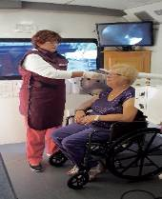
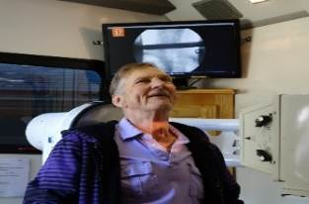
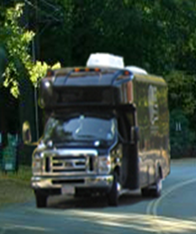
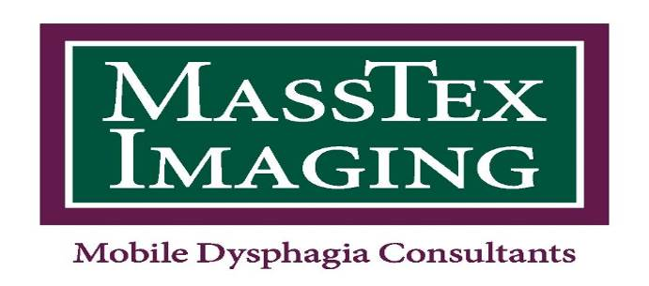
Proudly Serving New England. CT, MA, ME, NH, RI
MTI Interactive & Informative Presentations on Swallowing and Swallowing Disorders:

- Dysphagia Management For Individuals With Developmental Disabilities
- Symptoms of Dysphagia – Purpose of Instrumental Assessment
- Looking at Oral, Pharyngeal & Esophageal Stage - Swallow Videos
for D
Thursday, October 5th, 2017 1 – 2:30pm

Location: BAMSI Administrative Office
225 Foxborough Boulevard
Foxboro, MA
Registration by 9/28/17 to raquel.pereira@state.ma.us
Please provide two-week notice when requesting accommodations

Presented by:
Joan Kelly Arsenault, MA, CCC/SLP, BCS-S, Board Certified Specialist in Swallowing and Swallowing Disorders Speech-Language Pathologist, Chief Executive Officer, Managing Member LLC

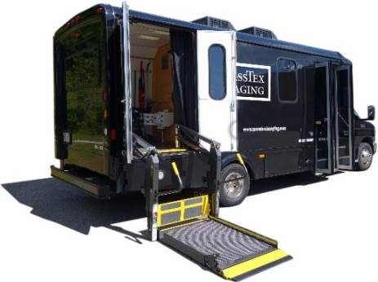
Founded in 2006, MassTex Imaging, LLC is the leading New England medical provider of Mobile Dysphagia Consultations. A dysphagia consultation includes; the Gold Standard, Modified Barium Swallow Study (MBSS), a Physician Consultation and an Esophageal Assessment to the Stomach with immediate results for patient care. Proudly serving pediatrics, adults and seniors.
Your mobile partner in Swallowing disorders!

www.massteximaging.com
800.508.MBSS (6277)
mbsonline@massteximaging.com


DIRECTIONS

DDS Brockton Area Office
60 Main Street, 3rd floor
Brockton, MA 02301
774-296-6090
Take Rte 24 to Rte 123 (Brockton) Exit 17. Follow Rte 123 (Belmont St.) to Main Street. Take a left on Main Street. Go through three set of lights. Brockton Office is on your right after the 3rd set of lights(Center Street). Across the street from Neighborhood Health Center.
Please note that this office is Fragrance Free

DDS Cape Cod & Islands Area Office
181 North Street, Hyannis, MA 02601
(508) 771-2595
From West & Central Mass.
Turnpike to exit 11Route I 495 South - Route 495S becomes Rte 25. Cross Bourne Bridge and
travel 3/4 around rotary. Following Route 6 toward Hyannis/Sandwich. Approximately 5 miles down the road, turn at traffic light, continue to follow Route 6 EAST (Mid- Cape Highway) to Hyannis
Take Exit 6 Take RIGHT at end of ramp, which is Route 132, Hyannis. Go 1.5 miles and take
slight right onto Bearses Way. Continue for 1.8 miles and go half way around the round-about onto Bearses Way which becomes High School Rd. EXT. Turn right onto North Street at the lights.
DDS is located on the left @ 181 North Street next to McDonalds.

DDS Fall River Area Office
1 Father DeValles Blvd 3rd floor
Fall River, MA 02723
(508) 730-1209
From North of Fall River take Route 24 South to I-195 West. From I-195 West take Exit 8A –
Rt. 24 South. Then take Exit 2 – Eastern Ave./Brayton Ave. Turn right at end of ramp onto
Brayton Ave. Follow Brayton Ave. to the second set of traffic lights (there will be a strip mall
with a Dunkin’ Donuts and Subway shop on the left side of Brayton Ave.). Turn Left onto Father DeValles Blvd. and follow to the end. Father DeValles Blvd. ends in the parking lot of the two
building complex. The DDS’s office is on the third floor of the West building (the 4-floor structure – look for DDS sign at the entrance).

DDS New Bedford Area Office
908 Purchase Street
New Bedford, MA 02740
(508) 992-1848
From 93 South to 24 South to exit 12 (140 South) to exit 2E (195 East) to exit 15 (Route 18 South –
Downtown). Follow to first set of lights. At lights take a right onto Elm Street. Follow Elm Street up
hill (Elm Street parking garage on right). Our building is the next one after the garage (Times Square
Building). Park in the garage or at a meter. If you enter the building from the back (parking lot entrance)
go to the right through brick archway and take the elevator to the third floor. If you enter by the front
entrance (near NB Jukebox nightclub) go straight past the club and take the elevator to the third floor.
The conference room is located on the second floor.
DDS Plymouth Area Office
40 Industrial Park Road, Suite 1
Plymouth, MA 02360
(508) 732-5700
From Route 3 North or South
Take exit 7 on to Route 44 West. Take the Cherry Street/North Plymouth Exit. Turn right at the
end of the off ramp on to Commerce Way. Take left at second set of lights. Follow to stop sign
and take a left. Follow RMV sign

*DDS Southeast Regional Office
151 Campanelli Drive, Suite B
Middleboro, MA 02346
(508) 866-5000

Southeastern Residential Services
151 Campanelli Drive, Suite B
Middleboro, MA 02346
(508) 910-3000

From Plymouth/Carver Rte 44W Taunton, to rotary, take 1st right onto Rte 18, follow Rte 18, take a right onto Campanelli Drive (office is across from the entrance to the Christmas Tree Shops distribution center -same parking lot as Eastern Bank)

From Raynham/Taunton Area Follow Rte 44E, to rotary, take 4th right onto Rte 18 follow Rte 18, take a right onto Campanelli Drive (office is across from the entrance to the Christmas Tree Shops distribution center -same parking lot as Eastern Bank)

South Shore EHS Center -DDS
South Coastal Office
220R Forbes Road
Braintree, Ma 02184
(781-3568850
FROM THE SOUTH (Plymouth/ Cape):
Take Rte. 3 North towards Boston. Keep left to take I-93 S via Exit 20A toward I-95 Canton
Take Exit 6 for Rte. 37 Granite St. Bear right at the end of the exit ramp on to Granite St.
At the second light, turn right onto Forbes Road. 220R Forbes Road is about half a mile down
Forbes Road and is behind the 4 story office building #220
220R Forbes Road is a one story building with the main entrance at the rear of the building

FROM ROUTE 24:
Merge onto I—93 N via EXIT 21A toward Boston. Take Exit 6 for Rte. 37 toward
W. Quincy/Braintree. Bear right at the end of the exit ramp onto Rte. 37/Granite St.
At first light, turn right onto Forbes Road. 220R Forbes Road is about half a mile down
Forbes Road and is behind the 4 story office building #220
220R Forbes Road is a one story building with the main entrance at the rear of the building

DDS Taunton/Attleboro Area Office
21 Spring Street,
Taunton, MA 02780
(508) 824-0614
From Route 24: Get off exit 12 – Route 140 west to Taunton. Go approximately 2.8 miles to
traffic light (Spring Street). Take a left. DDS is in the red brick building on the left, on the far side.

Wrentham Developmental Center
Emerald Street Wrentham, MA 02093
(508) 384-1600

From Cape Cod
Take Route 25/495 North. Take Route 1A (Plainville/Wrentham - Exit 15). Bear right off of
exit. Follow Route 1A into Wrentham center. Go straight through traffic light for approx. 1 mile.
Take a left onto North Street at blinking yellow light. Take third left (Finch road). Cottage 9 is
the first yellow building on the left. Please park in appropriate parking lots.

